1. A volcanologist needs to mesure the distance across the base of active volcano. Distance AB is measured at 1.5 km. Using a theodolite ( a sighting instrument used by surveyors) angle BCA is found to be 95.70. what is the distance across the base? /6marks

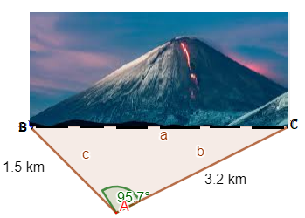

1. Solve the equation sin
2. Draw the graph of the following function

Y=

1. If f(x)= and g(x)= describe fog and prove that fog

Locate the vertical asymptotes ( s) and state the domain in set notation.

/7marks

1. Decompose into partial fractions
2. **Evaluate this limit**