UNIT 1. APPLICATIONS OF THERMODYNAMICS LAWS
Key unit competence: To evaluate applications of first and second laws of thermodynamics in real life.
INTRODUCTORY ACTIVITY

Mutesi is a parent of two children at a certain school. Before she takes them to school, she first makes sure that she prepares food and drinks for them and packs some in flasks so that her children can eat and drink during lunch time.
She then drives them to school before she reports to her working place and then from the school she then diverts to her working place which is about 5 km away from the school.
The parking yard at her work place is a plain place without any shade but she makes sure that her car is parked near a tree that is near the parking yard to prevent her car from different damages among which is destruction of tyres of her car.
- Explain why Mutesi makes use of flasks not normal utensils like metallic bowels while parking foods and drinks for her children.
- Is there heat exchange inside the flasks? Explain your reasoning.
- Imagine on a certain day these two children only eat food and leaves the drink in the flask and by mistake they forget flask in the store and her mother come to pick it the next day. Do you think the contents in the flask will be at the same temperatures? Explain all scientific phenomena that may be behind to either loss or gain in energy of the contents in the flask.
- Why do you think in most cases the outer covering of a flask is always made of a poor conductor? Still explain how quality and efficiency of these flasks can be improved by manufactures.
- As stated, Mutesi normally parks her car under a shade to prevent her car from being exposed to sunshine. Discuss, how during hot days the tyres of a car may burst.
- Her Car uses petrol in operation. During operation of her car, the engine draws fuel (Petrol) air mixture from the tank into the engine, explain all the processes that take place in the engine.

1.1 Internal energy and total energy of a system
ACTIVITY 1.1
You are in a small room with one door and no window. On a hot day you happen to be to take rest to wake up, you find yourself sweating and the whole room is hot.
- What do you think was the cause of sweating?
- You left the room closed, what led to the rise in the temperature in your room?
- Imagine you left the door open, do you think the temperatures in the room would be the same? Explain your reasoning.
- Of the three physical quantities, Pressure, Volume and temperature, which one(s) changed?
Thermodynamics refers to the study of heat and its transformation into mechanical energy.
In thermodynamics, the internal energy is one of the two cardinal state functions of the state variables of a thermodynamic system. It refers to total energy contained within the system excluding the kinetic energy of motion of the system and the potential energy of the system due to external forces. It keeps account of the gains and losses of energy of the system.
The internal energy of a system may be changed
- by heating the system
- by doing work on it,
- by adding or taking away matter.
The thermal energy is the portion of internal energy that changes when the temperature of the system changes. Sometimes the term thermal energy is used to mean internal energy.
Heat is defined as the transfer of energy across the boundary of a system due to a temperature difference between the system and its surroundings. When you heat a substance, you are transferring energy into it by placing it in contact with surroundings that have a higher temperature. For example, when you place a pan of cold water on a stove burner, the burner is at a higher temperature than the water, and so the water gains energy. We shall also use the term heat to represent the amount of energy transferred by this method.
In daily life, we recognize the distinct difference between internal energy and heat. Nevertheless, we refer to quantities using names that do not quite correctly define the quantities, but which have become entrenched in physics tradition based on these early ideas. Examples of such quantities are heat capacity and latent heat.
The heat transfer is caused by a temperature difference between the system and its surroundings. However, in some systems there are no temperature and pressure gradients, such systems are said to be in thermodynamic equilibrium.
APPLICATION ACTIVITY 1.1
- Explain the meaning of the following terms as applied in thermodynamics
i) Heat
ii) Internal energy of a system
- With clear explanations, explain how the internal energy of a system can be altered.`
- Basing on real life examples, point out areas where there are energy changes. Explain the need for these changes for each stated system.
- Two bodies are at different temperatures. They are then brought into contact. Will there be sharing of temperature or each body will remain at its temperature. Explainthis scientific phenomenon.

1.2 Work done by an expanding gas
ACTIVITY 1.2
- Gas is a state of matter with particles that are in constant motion and held together by weak forces. Like any other state of matter, if a certain gas is confined in a container, it can do some work. How do you know that a gas has done some work?
- A gas is confined in a room with fixed and strong walls. Suppose the gas particles are allowed to interact, can the particles make the walls be displaced? Basing on your reasoning, do we say that the gas has done work.
- Explain changes that may take place if a gas expands.
Consider a gas contained in a cylinder fitted with a movable piston. At equilibrium, the gas occupies a volume V and exerts a uniform pressure P on the cylinders walls and on the piston. If the piston has a cross-sectional area A, the force exerted by the gas on the piston is F = PA. Now let us assume that we push the piston inward and compress slowly to allow the system to remain essentially in thermal equilibrium.
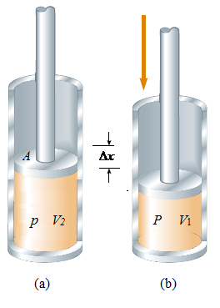
Fig.1. 1Work is done on a gas contained in a cylinder at a pressure P as the piston is pushed downward so that the gas is compressed.
Using the same procedure as in work done by the force of pressure, we find the same relation but having a negative sign. The force is exerted in opposite direction and the final volume is less than the initial one.
Then we have:
The total work done on the gas as its volume changes from V_{i} to V_{f} is given by the above equation:
If the gas is compressed, ΔV is negative and the work done on the gas is positive (Work done by the gas is positive) and if the gas expands, ΔV is positive and the work done on the gas is negative(Work done on the gas is negative). If the volume remains constant, the work done on the gas is zero. Thus, no work done. To evaluate this relation, one must know how the pressure varies with volume during the process.
The work done on a gas in a quasi-static process that takes the gas from an initial state to a final state is the negative of the area under the curve on a PV diagram, evaluated between the initial and final states.
As Figure 1.1.indicates, for the processes of compressing a gas in the cylinder, the work done depends on the path taken between the initial and final states.
Example | 1.1

1.a) A ball is pumped at a constant pressure of 2x10⁵ Pa and the volume of the ball changed from 2 L to 5 L. Calculate the work done by the gas.
b) If for the same system, the volume remained the same. What would be work done by the gas.
Solution
(a) From
From the Question P=2x10⁵ Pa,V_{f} =5 L, V_{i} =2 L,
(b) From the equation
But thus
Comment: There is no work done by the gas since the volume remained constant.
APPLICATION ACTIVITY 1.2
1. Explain the effect of the nature of the walls of a container on work done by the gas.
2. How does expansion of a gas in a certain container, affect the shape and size of the container. How can this be minimized?
3. Gas in a container is at a pressure of 1.6´10⁵ Pa and a volume of 4.0 m³. What is the work done on or by the gas if:
- It expands at constant pressure to twice its initial volume?
- It is compressed at constant pressure to one-quarter of its initial volume?
4. An engine cylinder has a cross-sectional area of 0.010 cm². How much work can be done by a gas in the cylinder if the gas exerts a constant pressure of $7\text{.}5×{\text{10}}^{5} \text{Pa}$ on the piston, moving it a distance of 0.040 m?

1.3 First law of thermodynamics and applications.
ACTIVITY 1.3
- Imagine you are boiling water in a closed container (say a closed saucepan) on a gas stove. Explain all changes that may take place in the saucepan.
- From your suggestions in 1) above, explain how the applied heat may lead to change in internal energy of water and even displacement of saucepans cover.
- From 2) above, deduce a mathematical relation that relates heat supplied, internal energy of water and work done by water.
- a) What is the boiling point in ºC of pure water?
b) If extra heat is applied to water at its boiling point, can its temperature change?
c) Imagine hot water at 78 ⁰C is put in a flask and it remains there when the temperature is not changing and even the volume. There is no heat added from the surroundings nor heat removed from the system. Explain all scientific processes that take place in this flask.

1.3 1 First law of Thermodynamics.
The first law of thermodynamics is an extension of the law of conservation of energy
It states that the change in internal energy of a system is equal to the heat added to the system minus the work done by the system
Where
- ΔU is the change in internal energy
- Q is the heat supplied to the system
- W is the work done by the system
This equation is known as the first law of thermodynamics
Note: A positive W is the work done on the system.
When n moles of a gas are considered, the amount of heat supplied at constant pressure is
,
whereas the amount of heat supplied at constant volume would be
Where
- C_{P} is the molar heat capacity at a constant pressure
- C_{V} is the molar heat capacity at a constant volume.
Example | 1.2

1. The internal energy of a system is initially 27 J. A total of 33 J of energy is added to the system by heat while the system does 26 J of work. What is the systems final internal energy?
Answer

1.3.2 Relationship between c_{p} and c_{v}
Consider one mole of a gas at a pressure P, temperature T and volume V, heated to cause the same temperature change, ∆T first at constant volume and secondly, at constant pressure.
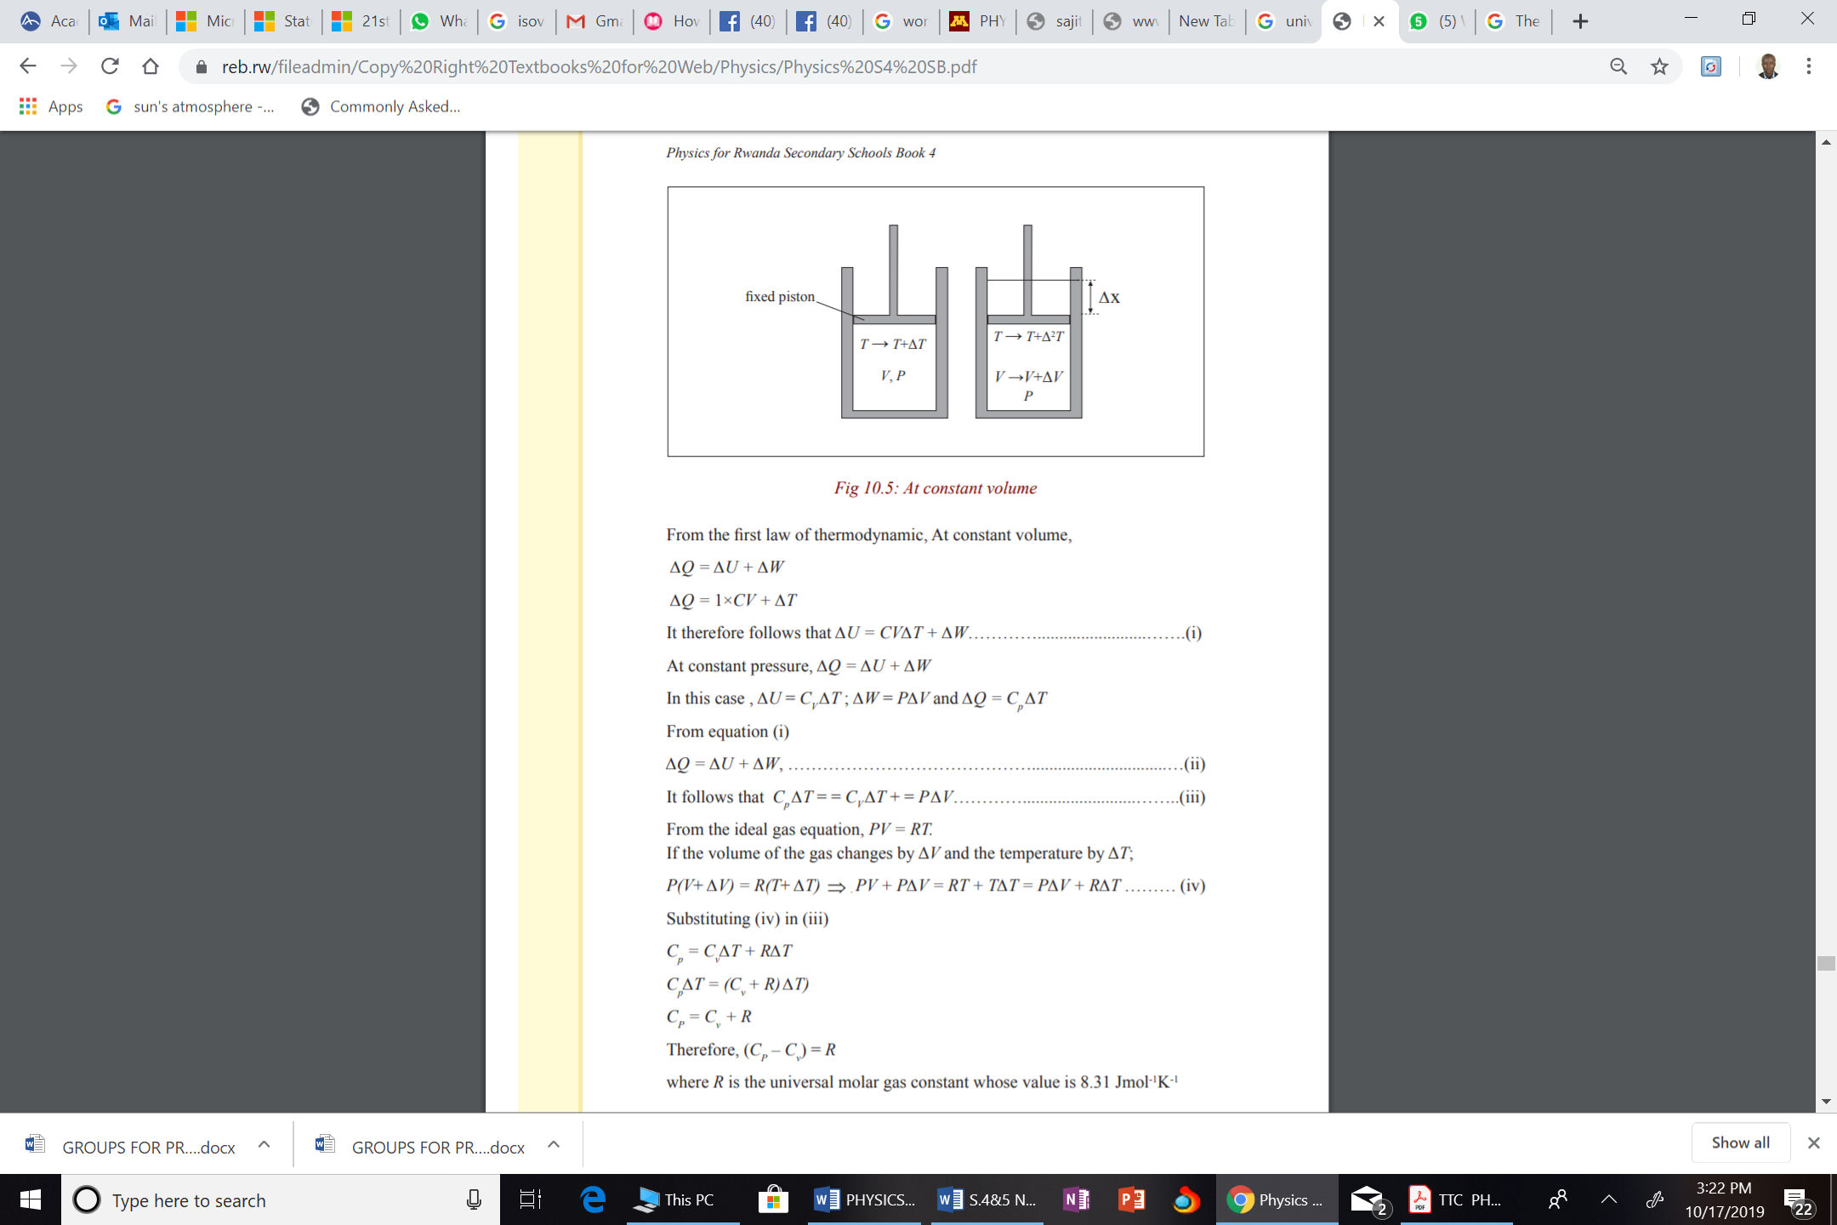
Fig.1. 2A gas in cylinder heated at constant pressure
For syringe with a fixed piston, the gas is heated at a constant volume. Therefore
(i)
Since the system was heated at constant Volume and the temperature changed by 1K(Molar heat capacity at constant Volume), Heat supplied into the system.
But hence
For syringe with a movable piston, the gas is heated such that the volume changes thus work is done. Therefore
Since the gas is heated at a constant pressure (molar heat capacity at constant pressure) ,the heat supplied therefore, the above equation becomes
(ii)
Substitute i) into ii)
(iii)
Before the system was heated, (x)
After warming (y)
Because there was a rise in temperature by 1K.
Subtracting x from y
Therefore equation (iii) becomes
where R is the universal gas constant.
The first law of thermodynamics is a special case of the law of conservation of energy that encompasses changes in internal energy and energy transfer by heat and work. It is a law that can be applied to many processes. We have discussed two ways in which energy can be transferred between a system and its surroundings.
One is work done on the system, which requires that there be a macroscopic displacement of the point of application of a force. The other is heat, which occurs on a molecular level whenever a temperature difference exists across the boundary of the system. Both mechanisms result in a change in the internal energy of the system and therefore usually result in measurable changes in the macroscopic variables of the system, such as the pressure, temperature, and volume of a gas.
The increase in internal energy of a system is the sum of the work done on the system and the heat supplied to the system.
One of the important consequences of the first law of thermodynamics is that there exists a quantity known as internal energy whose value is determined by the state of the system. The internal energy is therefore a state variable like pressure, volume, and temperature.
The first law of thermodynamics is an energy conservation equation specifying that the only type of energy that changes in the system is the internal energy ΔU.
Example | 1.3

1. Fill in the boxes with -, +, or 0 for each of the following three terms in the first law of thermodynamics. For each situation, the system to be considered identified
Situation | System | Q | W | ΔU
- Rapidly pumping up a bicycle tire | Air in the pump
- Pan of room-temperature water sitting on a hot stove | Water in the pan
- Air Quickly leaking out of a balloon | Air originally in the balloon.
Answer
Situation | System | Q | W | ΔU
- Rapidly pumping up a bicycle tire | Air in the pump | 0 | + | +
- Pan of room-temperature water sitting on a hot stove | Water in the pan | + | 0 | +
- Air Quickly leaking out of a balloon | Air originally in the balloon. | 0 | - | -
2. 20.5 kJ of heat is supplied to a system, and 10.8 kJ of work is done on the system. What is the change in internal energy of the system?
Answer
The change in internal energy:

1.3.3 Applications of first law of Thermodynamics.
The first law of thermodynamics that we discussed relates the changes in internal energy of a system to transfers of energy by work or heat. In this case we shall consider applications of the first law to processes through which a gas is taken as a model.
ISOBARIC PROCESS
A process that occurs at constant pressure is called an isobaric process. In such processes, the values of the heat and the work are both usually nonzero. The work done during isobaric process is simply
Where
- P is the constant pressure,
- V_{f} is the final volume
- V_{i} is the initial volume.
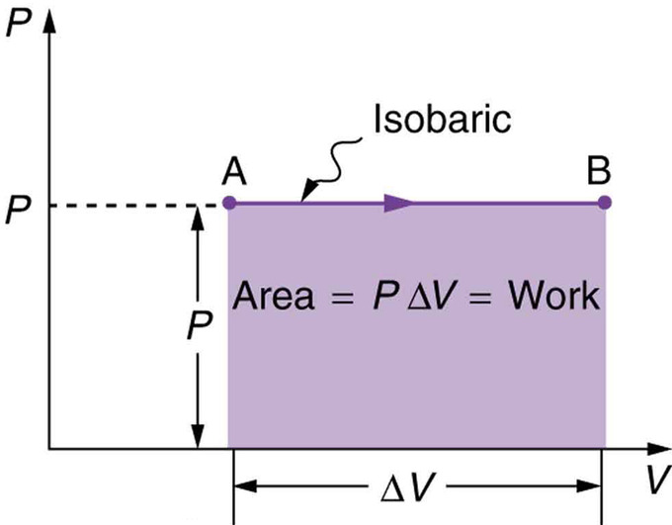
Fig.1. 3 P-V graph showing isobaric process
As indicated from the fig above AB is an Isobaric process
From first law of thermodynamics,
This implies that work done during isobaric process is given by
ISOVOLUMETRIC PROCESS/ISOCHORIC PROCESS
A process that takes place at constant volume is called an isovolumetric process.
In such a process, the value of the work done is zero because the volume does not change. Hence, from the first law we see that in an isovolumetric process, because
W = 0,
ΔU = Q (isovolumetric process)
This expression specifies that if energy is added by heat to a system at constant volume, then all of the transferred energy remains in the system as an increase in its internal energy.
For example, when a can of spray paint is thrown into a fire, energy enters the system (the gas in the can) by heat through the metal walls of the can. Consequently, the temperature, and thus the pressure in the can increases until the can possibly explodes.
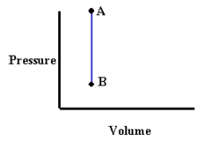
Fig.1. 4P-V graph showing isovolumetric process
From the figure 1.4 above, process AB takes place at a constant Volume (volume doesnt change).
ISOTHERMAL PROCESS
A process that occurs at constant temperature is called an isothermal process.
A plot of P versus V at constant temperature for an ideal gas yields a hyperbolic curve called an isotherm.
Fig.1. 5The PV diagram for an isothermal expansion (i→f) of an ideal gas from an initial state to a final state. The curve is a hyperbola.
The internal energy of an ideal gas is a function of temperature only. Hence, in an isothermal process involving an ideal gas,
ΔU = 0.
For an isothermal process, then, we conclude from the first law that the energy transfer Q must be equal to the negative of the work done on the gas, that is,Q = -W
Any energy that enters the system by heat is transferred out of the system by work, as a result, no change in the internal energy of the system occurs in an isothermal process.
It can be noted from the graph that PV=constant. This symbolizes that under isothermal, the process obeys Boyles law where pressure is inversely proportional to the volume at a constant temperature.
Therefore, at constant temperature
PV = constant.
From the equation above, it can be deduced that if a gas is at conditions P₁V₁, the quantities can change to P₂V₂ with temperatures remaining constant. However, still at constant temperature, the system at P₂V₂ can still undergo the same change ( at constant temperature) to P₁V₁.Such processes are referred to as Reversible isothermal change.
CONDITIONS NECESSARY FOR AN ISOTHERMAL PROCESS TO TAKE PLACE
For an isothermal process to take place the following conditions must be satisfied
- The gas must be contained in a thin walled heat conducting vessel/container in good thermal contact with a constant temperature bath.
- The process must be carried out slowly to allow time for heat exchange to take place.
WORK DONE DURING ISOTHERMAL PROCESS.
Consider fig, a gas expands from V_{i} to V_{f} at a constant temperature. In this case, Work is done.
Considering n moles of a gas, the work done by a gas during isothermal process is given by
From where,
- n is the number of moles
- R is the universal gas constant = 8.3145 J / mol·K
- T is the temperature.
- V_{f} is the final Volume.
- V_{i}is the initial Volume.
From the above equation, the following can be drawn;
- When the gas expands (That is ), then W is positive.
- (When the gas is compressed (That is ), thus W is negative, meaning that work is done on the gas in compressing it.
Example | 1.4

1. A vessel containing 1.5x10⁻³ m³ of an ideal gas at a pressure of 8.7x10⁻² Pa and at a temperature 25 ⁰ C is compressed isothermally to halve its original volume.
Calculate the work done during this process. Comment on the sign of the answer (,
Answer
From
Comment.
The answer has a negative value. This shows that the work is don on to the gas (compressed).
APPLICATION ACTIVITY 1.3
1.Explain the meaning of the following terms as applied in thermodynamics and in each case sketch their P-V curves.
a) Isothermal process
b) Isovolumetric process
c) Isobaric process
2. One mole of an ideal gas expands at a constant pressure of 1.0325 x 10⁵ Pa from 2 L to 4 L. It then expands isothermally to a volume of 6 L at constant temperature of 298 K .
- Represent the whole process on a P-V curve.
- Using the values given in the question, calculate the final pressure reached by the gas.
- c). For each case, Calculate the work done.
- Assuming the gas at 6 L changed its pressure back to the original pressure still at constant temperature. What is the work done by the gas. Comment on the value of work done obtained.
3(a) (i) What is meant by a reversible isothermal change?
(ii) State the conditions for achieving a reversible isothermal change.

1.4 Second law of thermodynamics and applications
ACTIVITY 1.4
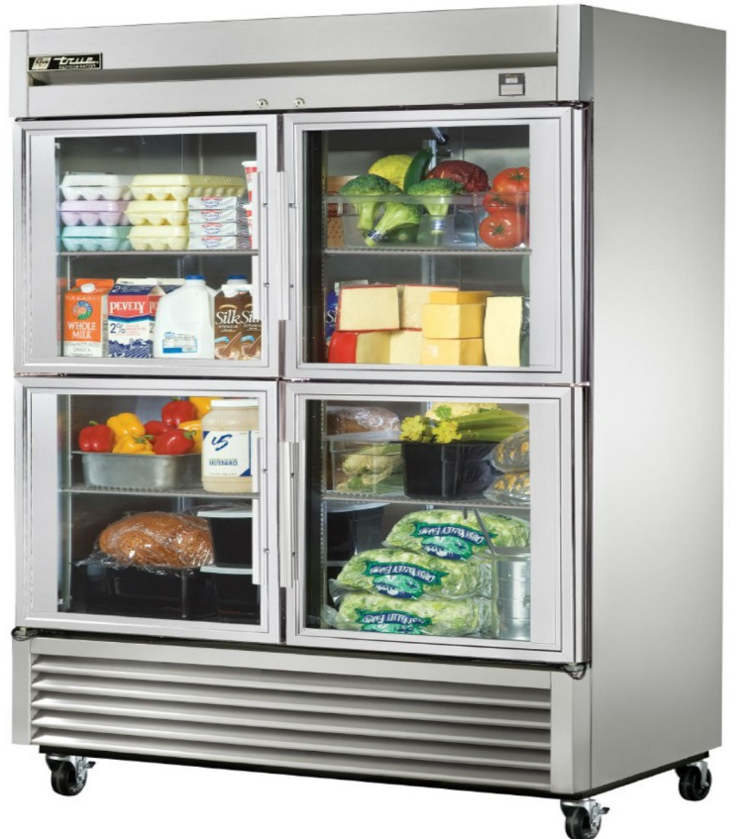
- Basing on your experience, explain how food can be cooled by a refrigerator.
- If a hot drink is put into a refrigerator and spends like 30 minutes. It cools down. Where does the heat from the drink go?
The first law of thermodynamics states that energy is conserved. There are, however, many processes we can imagine that conserve energy but are not observed to occur in nature. For example, when a hot object is placed in contact with a cold object, heat flows from the hotter one to the colder one, never spontaneously the reverse. If heat were to leave the colder object and pass to the hotter one, energy could still be conserved. Yet it doesnt happen spontaneously the reverse. As a second example, consider what happens when you drop a rock and it hits the ground. The initial potential energy of the rock changes to kinetic energy as the rock falls. When the rock hits the ground, this energy in turn is transformed into internal energy of the rock and the ground in the vicinity of the impact; the molecules move faster, and the temperature rises slightly. But have you seen the reverse happen, a rock at rest on the ground suddenly rise up in the air because the thermal energy of molecules is transformed into kinetic energy of the rock as a whole? Energy could be conserved in this process, yet we never see it happen.
There are many other examples of processes that occur in nature but whose reverse does not.
To explain this lack of reversibility, scientists in the latter half of the nineteenth century formulated a new principle known as the second law of thermodynamics.
The second law of thermodynamics is a statement about which processes occur in nature and which do not. It can be stated in a variety of ways, all of which are equivalent. One statement is that: Heat can flow spontaneously from a hot object to cold object; heat will not flow spontaneously from a cold object to a hot object.
The development of a general statement of the second law of thermodynamics was based partly on the study of heat engines. A heat engine is any device that changes thermal energy into mechanical work, such as steam engines and automobile engines.

1.4.1 Applications of second law of Thermodynamics
ADIABATIC PROCESS
As we noted, an adiabatic process is one in which heat is not allowed to enter or leave the system.
Therefore Q (heat added) is Zero
ΔU = -W
For example, if a gas is compressed (or expanded) very rapidly, very little energy is transferred out of (or into) the system by heat, and so the process is nearly adiabatic. Such processes occur in the cycle of a gasoline engine.Another example of an adiabatic process is the very slow expansion of a gas that is thermally insulated from its surroundings.
Suppose that an ideal gas undergoes an adiabatic expansion. At any time during the process, we assume that the gas is in an equilibrium state, so that the equation of state PV = nRT is valid. As expressed below, the pressure and volume of an ideal gas at any time during an adiabatic process are related by the expression
whereis assumed to be constant during the process. Thus, we can see that all three variables in the ideal gas law, P, V, and T change during an adiabatic process.
However, at conditions P₁, and V₁, the system may change to, P₂V₂ when there is no heat allowed to enter or leave the system, the process is termed to be reversible adiabatic process. Such processes that are both adiabatic and reversible are termed as isentropic process
Fig.1. 6
CONDITIONS THAT ARE NECESSARY FOR AN ADIABATIC CHANGE TO OCCUR
For an adiabatic process to be achieved,
- the gas must be contained in a thick walled and perfectly insulated isolated container.
- The process must be carried out rapidly to avoid any possible heat exchanges between the gas system and the surroundings.
WORK DONE DURING ADIABATIC PROCESS.
Since all quantities may change during adiabatic, work is always done and it is calculated from the equation below
Where
- W is the work done during adiabatic
- where , the ratio of heat capacities
- P is the pressure of the gas
- V is the volume occupied by the gas.

1.4.2 Carnot cycle and Carnot engine
In 1824 a French engineer named Sadi Carnot described a theoretical engine, now called a Carnot engine, which is of great importance from both practical and theoretical viewpoints. He showed that a heat engine operating in an ideal, reversible cyclecalled a Carnot cyclebetween two energy reservoirs is the most efficient engine possible.
Such an ideal engine establishes an upper limit on the efficiencies of all other engines. That is, the net work done by a working substance taken through the Carnot cycle is the greatest amount of work possible for a given amount of energy supplied to the substance at the higher temperature. Carnots theorem can be stated as follows:
No real heat engine operating between two energy reservoirs can be more efficient than a Carnot engine operating between the same two reservoirs.
No Carnot engine actually exists, but as a theoretical idea it played an important role in the development of thermodynamics.
The idealized Carnot engine consisted of four processes done in a cycle, two of which are adiabatic (Q = 0) and two are isothermal (ΔT = 0).
This idealized cycle is shown in figure 1.7.
Fig.1. 7 Carnot Cycle.
Each of the processes was considered to be done reversibly. That is, each of the processes (say, during expansion of the gases against a piston) was done so slowly that the process could be considered a series of equilibrium states, and the whole process could be done in reverse with no change in the magnitude of work done or heat exchanged. A real process, on the other hand, would occur more quickly; there would be turbulence in the gas, friction would be present, and so on. Because of these factors, a real process cannot be done precisely in reverse, the turbulence would be different, and the heat lost to friction would not reverse itself. Thus real processes are irreversible.
In the figure 1.7 (Carnot cycle), heat engines work in a cycle, and the cycle for the Carnot engine begins at point a on the PV diagram.
- The gas is first expanded isothermally, with addition of heat Q_{H}, along the path ab at temperature T_{H}.
- Next the gas expands adiabatically from b to c, no heat exchanged, but the temperature drops to T_{L}.
- The gas is then compressed at constant temperature T_{L}, path cd, and het Q_{L} flows out.
- Finally, the gas is compressed adiabatically, path da, back to its original state.
Carnot showed that for an ideal reversible engine, the heats Q_{H} and Q_{L} are proportional to the operating temperatures T_{H} and T_{L} (in Kelvin), so the efficiency can be written as:
This equation gives a Carnot (ideal) efficiency. It expresses the fundamental upper limit to the efficiency. Real engines always have an efficiency lower than this because of losses due to friction and the like. Real engines that are well designed reach 60 to 80% of the Carnot efficiency.

1.4.3 Diesel engine
In an internal combustion engine (used in most automobiles), the high temperature is achieved by burning the gasoline-air mixture in the cylinder itself (ignited by the spark plug), as described in figure 1.8.
Fig.1. 8Four-stroke-cycle internal combustion engine
On the figure 1.8 above, the following takes place.
- the gasoline-air mixture flows into the cylinder as the piston moves down;
- the piston moves upward and compresses the gas;
- the brief instant when firing of the spark plug ignites the highly compressed gasoline-air mixture, raising it to a high temperature.
- the gases, now at high temperature and pressure, expand against the piston in this, the power stroke
- the burned gases are pushed out to the exhaust pipe; when the piston reaches the top, the exhaust valve closes and the intake valve opens, and the whole cycle repeats. (a), (b), (d) and (c) are the four strokes of the cycle.

1.4.4 Idealized diesel cycle
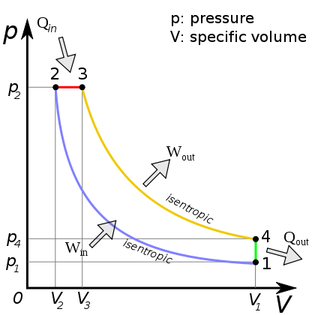
Fig.1. 9 Ideal diesel cycle
From P-V diagram for the Ideal Diesel cycle, the cycle follows the numbers 1-4 in clockwise direction. The image on the top shows a P-V diagram for the ideal Diesel cycle; where P is pressure and V is specific volume. The ideal Diesel cycle follows the following four distinct processes (the color references refers to the color of the line on the diagram.
- Process 1-2 is isentropic (adiabatic) compression of the fluid (blue color).
- Process 2-3 is reversible (isobaric constant pressure heating (red).
- Process 3-4 is isentropic (adiabatic) expansion (yellow).
- Process 4-1 is reversible constant volume cooling (green).
The Diesel is a heat engine; it converts heat into work. The isentropic processes are impermeable to heat; heat flows into the loop through the left expanding isobaric process and some of it flows back out through the right depressurizing process, and the heat that remains does the work.
Work in (W_{in}) is done by the piston compressing the working fluid.
Heat in (Q_{in}) is done by the combustion of the fuel.
Work out (W_{out}) is done by the working fluid expanding on to the piston (this produces usable torque).
Heat out (V_{out}) is done by venting the air.

1.4.5 Refrigirator
A refrigerator is a device used to cool substances. It cools things by evaporation of a volatile liquid called Freon. The coiled pipe around the freezer at the top contains Freon which evaporates and takes latent heat from the surroundings so causing cooling. The electrically driven pump removes the vapor and forces it into the heat exchanger (pipes with cooling fins outside the rear of the refrigerator). Here the vapor is compressed and liquefies giving out latent heat of vaporization to the surrounding air. The liquid returns to the coils around the freezer and the cycle is repeated. An adjustable thermostat switches the pump on and off, controlling the rate of evaporation and so the temperature of the refrigerator.
The operating principle of refrigerators is just the reverse of a heat engine. Each operates to transfer heat out of a cool environment into warm environment.
Fig.1. 10. Schematic diagram of energy transfers for a refrigerator
As diagrammed in the figure 1.10, by doing work W, heat is taken from a low-temperature region, Q_{C} (such as inside a refrigerator), and a greater amount of heat is exhausted at a high temperature, Q_{H} (the room). You can often feel this heat blowing out beneath a refrigerator.
The work is usually done by an electric compressor motor which compresses a fluid, as illustrated in figure 1.11.
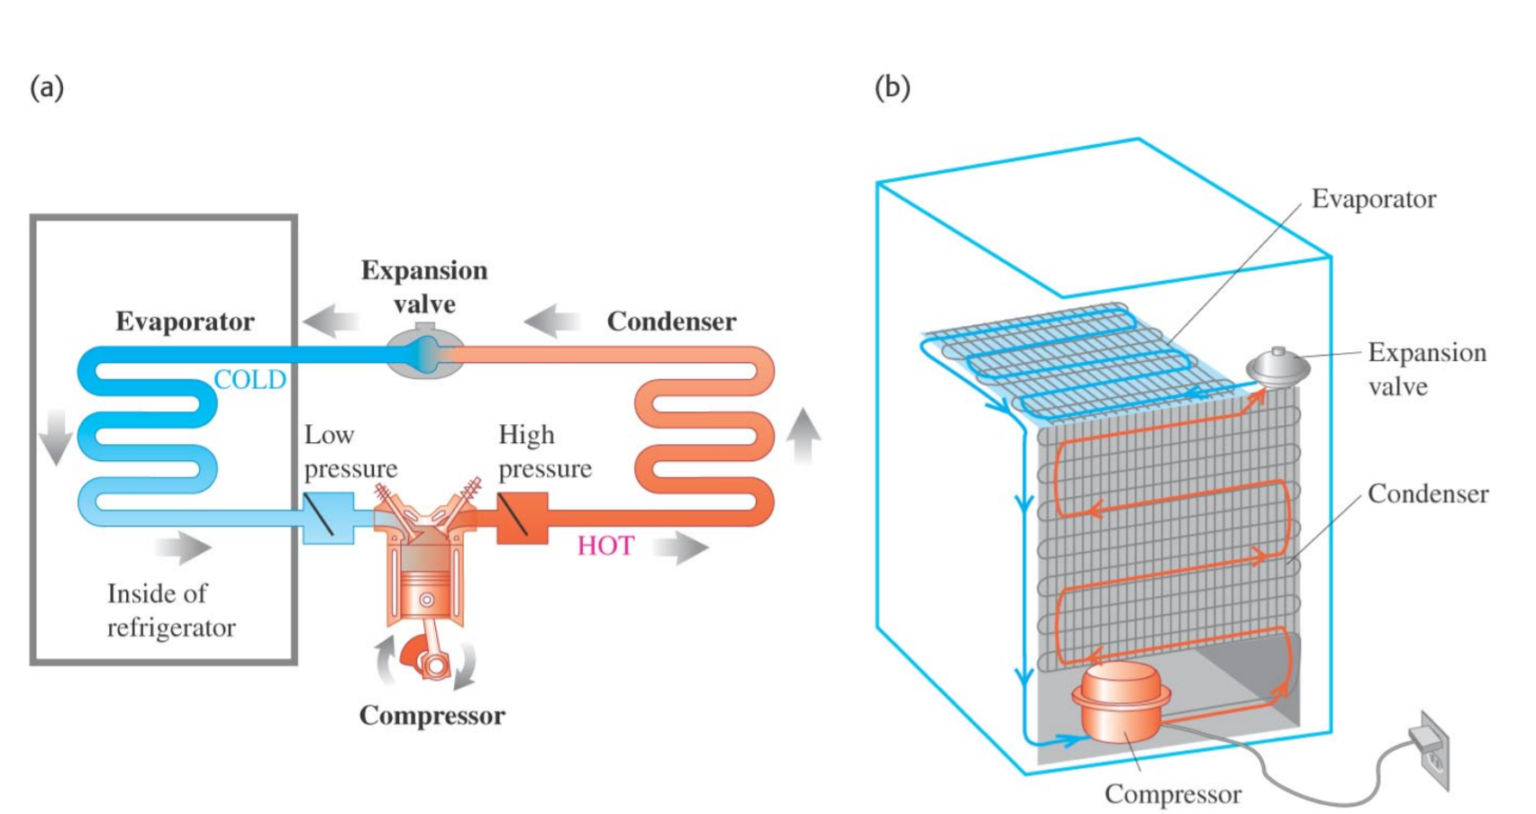
Fig.1. 11 Typical refrigerator system
In figure 1.11(a) above, the electric compressor motor forces a gas at high pressure through a heat exchanger (condenser) on the rear outside wall of the refrigerator. Where Q_{H} is given off and the gas cools to become liquid. The liquid passes from a high-pressure region, via a valve, to low-pressure tubes on the inside walls of the refrigerator; the liquid evaporates at this lower pressure and thus absorbs heat QL from the inside of the refrigerator. The fluid returns to the compressor, where the cycle begins again.
A perfect refrigerator, one in which no work is required to take heat from the low-temperature region to the high temperature region is not possible. This is Clausius statement of the second law of thermodynamics, already mentioned can be stated formally as:
No device is possible whose sole effect is to transfer heat from one system at a temperature T_{L} into a second system at a higher temperature T_{H}.
To make heat flow from a low-temperature object (or system) to one at a higher temperature, work must be done. Thus, there can be no perfect refrigerator.
The coefficient of performance (COP) of a refrigerator is defined as the heat Q_{L} removed from the low-temperature area (inside the generator) divided by the work W done to remove the heat:
This makes sense since the more heat, Q_{L}, that can be removed from inside the refrigerator for a given amount of work, the better (more efficient) the refrigerator is. Energy is conserved, so from the first law of thermodynamics we can write
.
Then we have:
For an ideal refrigerator (not a perfect one, which is impossible), the best one could be:
Example | 1.6

1. An ideal refrigerator-freezer operates with a COP = 7.0 in a 24 ºC room. What is the temperature inside the freezer?
From the equation of COP,
Changing temperatures into Kelvins 24⁰C+273=297 K
Solving the Equation T_{L}=259.875 K=-13.125 ⁰C

1.4.6 Heat engine
Any device that transforms heat into work or mechanical energy is called heat engine
All heat engines absorb heat from a source at high temperature, perform some mechanical work, and discard heat at a lower temperature.
The process in heat engine is cyclic and therefore there is no change in internal energy.
This implies
Thus, from first law of thermodynamics,and
Thus
This implies that all heat supplied into the system/engine is used to do work.
Note: A cyclic process is one which comes back to its initial state. The graph of a cyclic process is always a closed graph.

STRUCTURE OF HEAT ENGINE.
A heat engine has a hot reservoir at temperature T_{H} and a cold reservoir at temperature T_{C}; Q_{H} flows in from the hot reservoir and Q_{C} flows out to the cold reservoir.
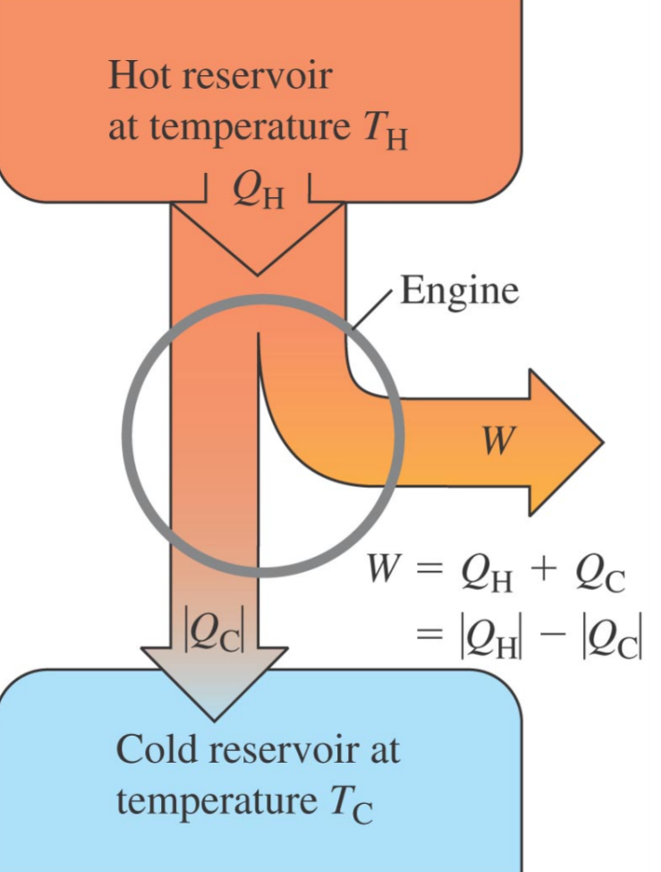
Fig.1. 12 Structure of heat engine
The net heat absorbed per cycle is
which is also the work done:
EFFICIENCY OF HEAT ENGINES.
The efficiency of the engine as the fraction of the heat input that is converted to work.
Ideally, we would like to convert all to work
Then and
Therefore efficiency is calculated from
This equation can also be expressed in terms of temperatures T (Must be in Kelvin)
Example | 1.7

1. A steam engine operates between 500 ºC and 270 ºC. What is the minimum possible efficiency of this engine?
Answer
From
Converting Temperatures into Kelvins T_{H}=500+273=773 K
T_{L} = 270+273=543 K.
HEAT ENGINES AND CLIMATIC CHANGE.
Most of air pollution is caused by the burning of fuels such as oil, natural gas etc. The air pollution has an adverse effect on the climate. Climate change is the greatest environmental threat of our time endangering our health. When a heat engine is running, several different types of gases and particles are emitted that can have detrimental effects on the environment.
Of concern to the environment are carbon dioxide, a greenhouse gas; hydrocarbons -- any of more than a dozen volatile organic compounds, nitrogen oxides; sulfur oxides; and particulate matter, tiny particles of solids, such as metal and soot. Engines emit greenhouse gases, such as carbon dioxide, which contribute to global warming. Fuels used in heat engines contain carbon. The carbon burns in air to form carbon dioxide. The Carbon dioxide and other global warming pollutants collect in the atmosphere and act like a thickening blanket and destroy the ozone layer. Therefore, the suns heat from the sun is received direct on the earth surface and causes the planet to warm up. Asa result of global warming, the vegetation is destroyed, ice melts and water tables are reduced. Heat engines especially diesel engines produce Soot which contributes to global warming and its influence on climate. The findings show that soot, also called black carbon, has a warming effect. It contains black carbon particles which affect atmospheric temperatures in a variety of ways. The dark particles absorb incoming and scattered heat from the sun; they can promote the formation of clouds that can have either cooling or warming impact; and black carbon can fall on the surface of snow and ice, promoting warming and increasing melting. Therefore soot emissions have significant impact on climate change . Similarly, some engines leak, for example, old car engines and oil spills all over. When it rains, this oil is transported by rain water to lakes and rivers. The oils then create a layer on top of the water and prevent free evaporation of the water.
APPLICATION ACTIVITY 1.4
- What is the generic name for a cyclical device that transforms heat energy into work?
- Refrigerator
- Thermal motor
- Heat engine
- Carnot cycle
- Otto processor
- The maximum possible efficiency of a heat engine is determined by
- its design.
- the amount of heat that flows.
- the maximum and minimum pressure.
- the compression ratio.
- the maximum and minimum temperature
- A heat engine does 9200 J of work per cycle while absorbing 22.0kcal of heat from a high-temperature reservoir. What is the efficiency of this engine? (one calorie, Cal equals 4.186 joules)
- A heat engine exhausts 8200 J of heat while performing 3200 J of useful work. What is the efficiency of this engine?
- (a) Explain why the cooling compartment of a refrigerator is always on top.
(b) The refrigerator cools substances by evaporation of a volatile liquid. Explain how evaporation causes cooling.
- The low temperature of a freezer cooling coil is -15ºC, and the discharge temperature is 30ºC. What is the maximum theoretical coefficient of performance?
- A restaurant refrigerator has a coefficient of performance of 5.0. If the temperature in the kitchen outside the refrigerator is 29 ºC, what is the lowest temperature that could be obtained inside the refrigerator if it was ideal?

Skills Lab 1
With the aid of the following materials, Design a working refrigerator
A pot, Charcoal, Cotton cloth, water. (You are not limited to use only these materials. You can use/add other materials that can enable you to design a better refrigerator.)
You can use either a drink or food to test whether your fridge is functioning.
Note: You should make sure that your setup is put in one place for proper inspection and your set up may work after several days (at least 3 days).

End Unit Assessment1
1. A steam engine operates between 500 ⁰C and 270 ⁰C. What is the maximum possible efficiency of this engine?
2. An engine manufacturer makes the following claims: the heat input per second of the engine is 9 kJ at 375 K. The heat output per second is 4 kJ at 225 K. Do you believe these claims?
3. 2500 J of heat is added to a system, and 1800 J of work is done on the system. What is the change in internal energy of the system?
4. A sample of an ideal gas goes through the process shown in Figure below. From A to B, the process is adiabatic; from B to C, it is isobaric with 100 kJ of energy entering the system by heat. From C to D, the process is isothermal; from D to A, it is isobaric with 150 kJ of energy leaving the system by heat. Determine the difference in internal energy
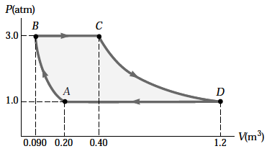
5. The internal energy of a system is initially 27 J. A total of 33 J of energy is added to the system by heat while the system does 26 J of work. What is the systems final internal energy?
6. An ideal gas is carried through a thermodynamic cycle consisting of two isobaric and two isothermal processes as shown in Figure below. Show that the net work done on the gas in the entire cycle is given by
