THE CONCEPT OF ICT
ICT ESSENTIAL FOR TEACHERS TRAINING
COMPUTER: Is electronic machine(devices) which is used to input data, processing , outing data and well as storing data in future use.
THE COMPONENTS O F COMPUTER:
THE MAIN PARTS OF COMPUTER: Hard ware and Soft ware
HARD WARE: .C PU .Central Processing unit
Mouse, Keyboard, cables,
SOFT WARE;
COMPUTER PERIPHERALS: other parts that we connect to the computer in order to increase capability,.eg
scanner, printers, microphones, speakers, projectors
BASICS PERIPHERALS :keyboard,
IT: all technology that we use to collect , processing, protect and storing information

THE FUNCTION OF COMPUTER PARTS
SCREEN: is used to display information 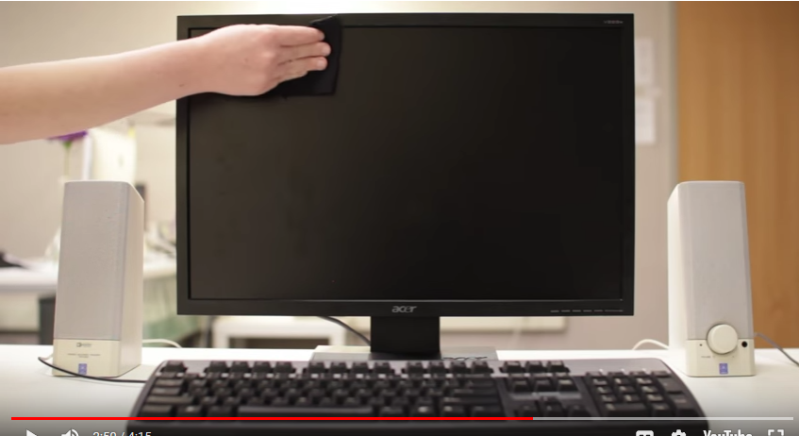
MOTHERBOARD: The main circuit all parts of machine are connected in.
CPU: CENTRAL UNIT, Computer case
RAM : is temporally , storage memory(working memory)
EXPANSION CARDS(SLOT):are used to increase ability(function) of machine.
POWER SUPPLY: to supply the power to the parts according to the needed
OPTIC DISC DRIVE: is used to put CDs in the place provided. used to install
SECONDARY STORAGE:

KEYBOARD: 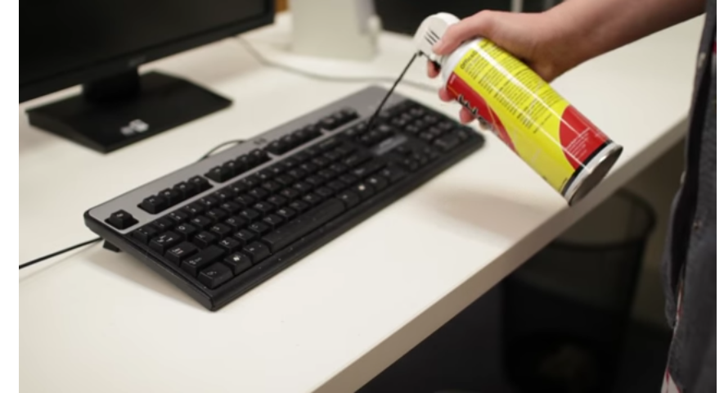

TRABLESHOOTING
Brower
Universal Foam Cleaning Agent
Lcd Water
Brush Tool
Clothes

PROTECTING YOUR COMPUTERS.
Your computer faces many potential threats, including Virus,malware,and hard drive failure. This is why it's important to do everything to do everything you can protect your computer and your files.
HOW TO INSTALL ANTI VIRSUS
Plug-in in antivirus in computer cd drive
Go to install →continue -activation key( password) put them in space provided

After filling this you go to
database update Run→ update click on it.

TYPES OF ANTI VIRUS: AVASTE,E SCAN,SMADAV, AVILA,NOLTON,KASPESKY.

SIMPLE SOLUITION S TO COMMON PROBLEM
PROBLEM :Power button will not start computer
application is running slowly .check whether memory is full or attacked by virus. we go to task manager .choose program ctrl.atl +delete.
THE MOUSE ,key board have stopped working .solution :Check Whether It Is Plugged On Correctly. Or search ,Control Panel→hard ware and sound→ mouse →Enable.
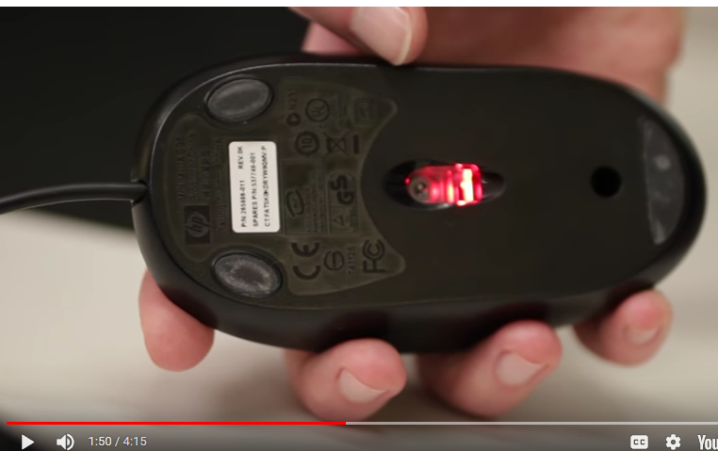
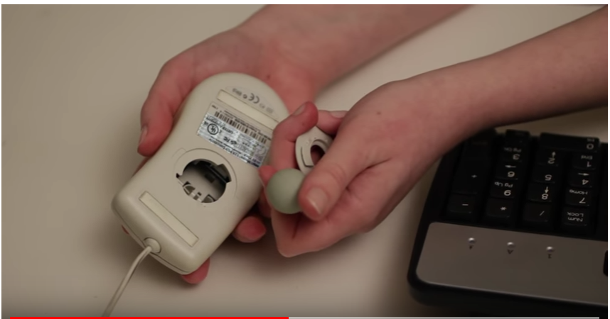

WORD PROCESSING
Application Soft Ware :
Operational Soft Ware:
soft ware: logical and electronic ;set of program that are used in order to perform a task .types of soft ware:
application software perform particular task, end user programs,. they are design to perform a specific task .eg window 7.window 10
Systems Soft Ware: managimagement of computer .
E.g. Operating System, help other program in running.
Start button -ms word-black document. start_search ms word and choose.
when you want to shut down you close all program-shut down.alt+-black document.start_search ms word and choose.
start -computer-local disk -program filles_micro soft office -light click -office
when you want to shut down you close all program-shut down.alt+f4 then enter.
search removable disk:all applications_pc you get _removable disk.
That how to access ms word.ctrl+n if there is other document that have been created.
if you have forgotten your document. go to start _recent document, and choose document.
how to save document .file_ save as choose where to save_ naming saved document _save.
An Other Way Ctrl+S. Save As Word97_2003 Document .
=rand(3,7) to create document.
shift+ctrl without moving and choose the letter to select.
when you want to formatting

GRAPHIC SOFT WARE : IS collection of programs in order to manipulate images on computer. in addition to static graphic ,there aer animation and video editing soft ware .eg :Picture Manager,Photo Shop,Ms Paint.
KEY INIT COMPETENCE
fundementals of working with images
- Taking Image Using Different Ways/Media
- Drawing Yours Using Application Software Such As Paint.
- Opening Existing Image With Different Application Software.
- Image Resizing.
- Rotating Image
- Printing Image
GRAPHIC FILE FORMATS
The Most Common Are These : JPEG OR JPG ,TIFF, PNG .
SAMPLE GRAPHIC SPFTWARE
- Adobe Photo Shop
- Corel Paint
- Auto Card
- Windows Paint.
MS

EMAIL ADDRESS:
girageena@gmail.com.write message to this and copy to iragenagilbert@yahoo.com.attach some thing on it. HOW I USE BROCK ,

MS EXCEL :Use of EXCEL IN T/LS AIDS ,MAKING SCHOOL REPORT,MAKING BOOK.9forum importance of spread sheet(recording) activities.Keeping of digital class work records.
MS EXCEL 2003,is usedv to store organise and analyse infos.financial isues,administrative isues

