Activity 3 (60 minutes):
Task the teachers to create a handout that they can use in their classes. Encourage them to take time to make their handout look as professional as possible. Ask the class to print their class notes both using the venue.

COMPUTER

Computer is an electronic device capable of inputting data, processing data, storage of data and outputting information.
A computer has two main parts which are: HADWARE and SOTWARE.

- COMPUTER HARDWARE
What is Hardware?
Hardware is the physical element of the computer, the parts you can see and touch examples:
Outside the system Unit: Mouse, keyboard, printer, Monitor or Screen, System Unit.
Inside the system Unit: Motherboard, Hard disk, power supply, RAM, …..
The computer work in four principals: Inputting data, storage of data, processing data and outputting information.

Bellow is the table of these principals and their devices:

Inputting data | Storage of data | Processing data | Outputting information
- Mouse  - Keyboard | - Hard disk  - RAM  - Memory Card | - Processor(CPU) | - Screen/Monitor  - Printer
 |  | (Central Processing Unit)
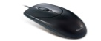 | 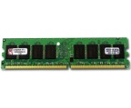 | 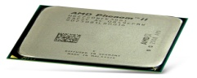 | 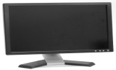

COMPUTER SOFTWARE

Computer software is the programs or instructions which user use for the tasks.
Computer software has two categories:
- Systems software
- Applications software
Examples of Applications software: Microsoft Office Word, Microsoft Office Excel, Microsoft Office Power Point ….
- Microsoft Office Word: Used to type a text, books, report and mailing.
The steps for starting Microsoft Office Word in your computer
- Click on start button
- Go to search
- Type “Word”
- The word processing it appear on your screen
- The last you double click on the icon
- Page where you can type appear.
When you type a text, or other document, for the future use you save it:
The steps for saving a document on your computer:

- Click on office button,
- Choice Save As
- Choice the location where you want to keep your document and double click
- Type the name of document in File name;
The second way is used the shortcut icon on task bar.

