**Google Groups**

**Blogs**

**Google Docs**

**Slide share**

**Wiks**

**Google Maps:**

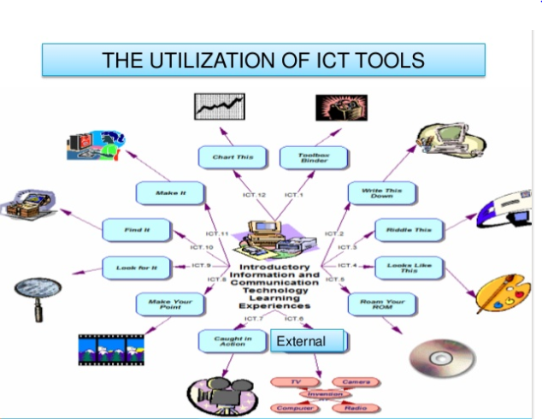

Flow this link: <https://www.slideshare.net/YESVITA/ict-tools-49037225>