IBIBAZO BY’ISUZUMA

Umwaka wa: mbere w’amashuri abanza Inyigisho: Ikinyarwanda
Umutwe wa 3: Umuryango
Ikibazo | Urwego rw’ubushobozi  (Bloom Taxonomy)
Vuga izina ry’iki gishushanyo  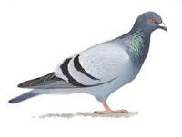 | 1.Kwibuka (remember)
Tahura inyuguti ya “n” mu magambo akurikira: inuma, inoni, Ana, urunana | 2.Kumva / gusobanukirwa (understand)
Soma amagambo akurikira: Ana, inoni, mama, Imana | 3.Gushyira mu bikorwa (apply)
Erekana inshingano za buri muntu mu bagize umuryango. | 4.Gusesengura (analyze)
Garagaza ukuntu abagize umuryango wawe bubahiriza buri wese inshingano ze | 5.Gusuzuma (evaluate)
Andika amagambo abiri kuri buri ngombajwi  - n: ......................., ...........................  - m:........................, .......................... | 6.Guhanga (create)

