G.S.MAYA II

Assignment N^{O}1: UNIT1Graphs of linear motion

1. What do you understand by:
(a) Accelerated motion.
(b) Non-accelerated motion.
(c) Give 2 examples for the motions in (a) and (b).
2. Show that:
(a) The slope of a displacement-time graph gives the velocity.
(b) The slope of a velocity-time graph gives acceleration.
(c) The area under the graph of velocity-time gives the displacement.

The data for a journey made by a car is given in table
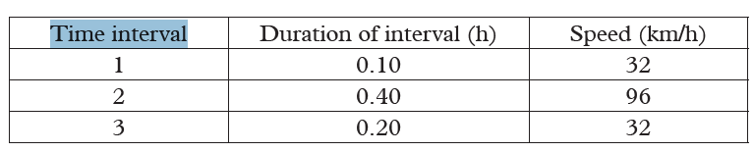
(a) How far does the car go in the first interval?
(b) Determine the total distance of the journey.
(c) Plot a graph of speed against time for this journey.
(d) Indicate the area on your graph which corresponds to the first 22.5 km/h of travel.

