Coding Club
Game Design Template

by _______________________ and ________________________

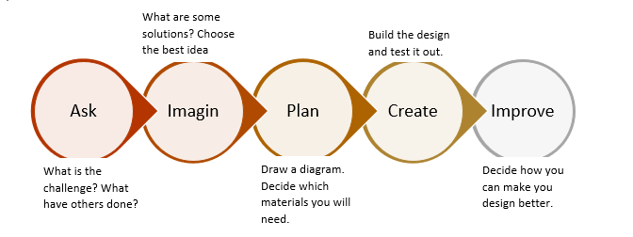
Ask & Imagine

What is your project about?

How will your project work?

What are the rules?

What are the goals?

How do you start?

How do you end or win?

Plan: Technical

The Stage will look like this

The Sprites will be these

The player will do these things:

Plan: Game Flow
Describe what happens when it happens, how to win, etc.

Sound Effects/Music
Background music

Sprite | Sound effect | To be recorded
1

2

Team Member Jobs

__________________ will work on ________________________

__________________ will work on ________________________

__________________ will work on ________________________

__________________ will work on ________________________

Together we will work on:

Create & Improve: Schedule & Testing
(to be filled out during Design review: ./../2021)

Week 1 Develop (Specify the part of the game you will be developing)

Week 2 Develop (Specify the part of the game you will be developing)

Week 3 Develop (Specify the part of the game you will be developing)

Week 4 Finish & Test

Week 5 Showcase

