Video outline – Dance Video
Module 3-4: stories and animations
Length: let`s aim for max 5 min
Voice-over: George?
Materials to bring: projector and speaker
Objective
- Learn about using loops to repeat a series of steps or tasks.
- Practice creating their own loops to perform dances and following a loop’s instructions
- Recognize patterns and shorten code
- Find mistakes and debug them

Overview/ in short
- Learners are divided into teams and make a choreography using repetitions and loops. After rehearsing the groups perform their choreography to each other (audience). The audience will try to write down the code (using repetitions and loops to make the code as short as possible).
- (In a second round, the performers, on purpose, make a mistake in the choreography. The other teams have to find the bug.)

Target Audience
- Lower and upper secondary learners
Elements in the video
- Algorithm
- Loops
- Pattern
- Repetitions
- Debugging
Bring
Speaker
Pen and paper
Computer
Script

Animation/Imagery | Voice Over | Notes/shoot location
George explaining | Through unplugged Coding activities, students can develop computational thinking skills through concepts such as algorithms, testing and debugging without using computers or other devices. So unplugged activities help students to understand the basics of coding without even touching a digital device! The only thing you need is creativity and imagination! Let’s get started! | Multimedia studio
- Voice over  - We see the music studio and music video in the scratch interface  https://scratch.mit.edu/projects/624224490  - The word ‘loops’ fly in. | In this video we will discover animations and stories in an unplugged way. In the Music studio in the Scratch interface you will find a lot of music video`s using loops. A loop repeats a sequence of steps. This is very handy, especially when performing a dance. Otherwise, the code would be very complex and long.  In this unplugged activity teams will perform a dance using loops and will try to find mistakes and debug them. | Scratch interface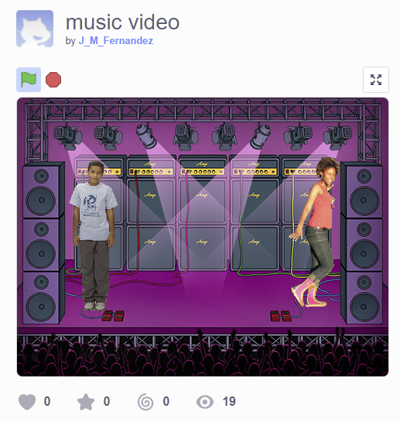
- Voice over  - We see an outdoor space big enough to perform dances  - We see pen and paper  - we maybe see a music box (not necessary)  - text with supplies needed floats in | Preparation  What do you need for this activity?  - Something separate to write on (blank paper, a pad, or small whiteboard)  - Something to write with (chalk, pen or pencil,…)  - Music box (or you can sing a song) | Outside - School (without the learners)
- Voice over  - Shot of groups  - Text ‘step 1’ flies in | How does it work?  Step 1. Divide the learners into teams (4-5 learners/team) | Outside - school
- Voice over  - Shot of the 3 steps in the song  - Text ‘step 2’ flies in | Step 2: Listen to the song and watch the 3 different moves in the song. | Outside – school  https://www.youtube.com/watch?v=O_TfIeAXTSI&ab_channel=theoisback
- Voice over  - Shot of a group rehearsing  - Text ‘step 3’ flies in | Step 3: Make a dance choreography using the 3 different steps in loops (repetitions of dance moves). Try to write it down as short as possible. For instance, instead of writing ‘clap clap clap jump jump jump’ you can write ‘3x clap’ and `3 x jump`. Also, include one mistake in the choreography. | Outside - school
- Voice over  - Shot of a group rehearsing  - Text ‘step 4’ | Step 4: Practice each of the moves until everyone feels secure with them. Make sure you can perform the dance, and everyone can remember the moves. | Outside - school
- Voice over  - Shot of performing group + other groups watching + trying to write down the code  - Text ‘step 5’  - The word ‘patterns’ and ‘bug’ flies in | Step 5: It’s showtime! The teams play/ sing the music and perform their dance taking turns. Make sure that the repetition is performed a few times before the mistake comes.  The audience must discover the code and mistake behind the dance steps. Try to recognize the patterns. A pattern is a repetition of multiple commands. This way, you can often make your algorithm much shorter! When the pattern is clear, it is also easier to find the mistake or bug. | Outside - school
- George explaining  - Words `loops`, ‘repetitions’ and ‘patterns’ fly in | Conclusions  Using loops and repetitions makes code easier and shorter. Recognizing these patterns is a very important skill you can develop further in unplugged activities.  Like all skills, programming is something you learn through practice, by writing code, rewriting it, and learning from others. Therefore, collaboration is key, especially when writing code. | Multimedia studio
Interview/reflection with learners | - What did you learn?  - How did you like this game?  - What did you learn about coding today? | School

