LESSON PLAN TEMPLATE
Term | Date | Subject | Class | Unit | Lesson | Duration | Class Size
2 | …….. | Mathematics | Senior 3 | 11 | 2 | 40 minutes | 25
Type of special Educational Needs to be catered for in this lesson and number of learners in each category |  |  |  | 2 students with learning difficulties
Unit title | Enlargement and similarity
Key Unit competence | By the end of this lesson , the learner should be able to solve problems enlargement and simulalarity
Title of the lesson | Similar polygons and similar triangles
Instructional objective | By the end of this lesson, the learner should be able to use scratch to define enlargement and similarity of polygons and triangles
Plan for this Class (location: in/outside) | This class will be held indoors
Learning Materials (For all learners) | Learners should have computers with scratch program.
References | Rwandan mathematics students book senior 3

Timing for each step  40 minutes | Description of teach and learning activity |  | Generic competences and Cross cutting issues to be addressed + a short explanation
 | Teacher activities | Learner activities
Introduction 10’ | Guide learners to draw 2 triangles that have same angles and have different size using scratch | Learners follow instructions provided by the teacher to draw 2 triangles of the same angles and different size | Critical thinking enhanced by coding using scratch,  Communication enhanced throug group discussion
Development of the lesson 20 minutes | -In group of 3 learners compare 2 triangles and present their findings  - Using scratch , guide learners to discover properties similarity of triangles  The following are script that are used in this lesson to draw a big size and small size triangle.  - Use 2 sprites, one for small size, another one for big size  Script for drawing small triangle  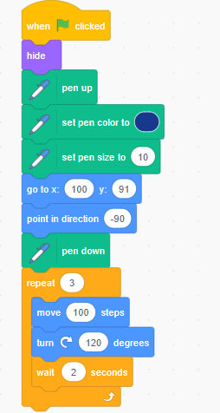  Script for drawing big triangle  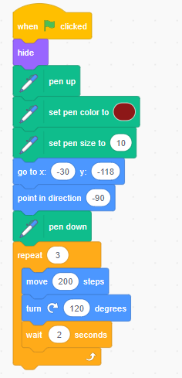  The result will be like:  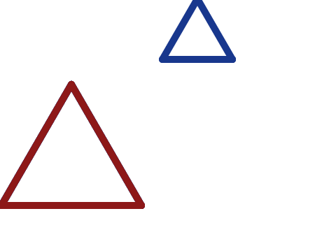  Exercise  Ask learners to draw two regular pentagon of different size | -Learners join group for discussion and present their findings.  -Discuss about properties of similar triangles using scripts of scratch  -Learners answer to the question asked by the teacher | Help learners slow learners  Critical thinking and cooperation enhanced by coding through scratch and group discussion
Conclusion (10’) | Guide learners to draw a conclusion on similar geometric figures | Two geometric figures are similar if and only if they have the same angles and different size
Teacher self-evaluation | The lesson is well conducted when the expected outcome are attained

