LESSON PLAN TEMPLATE
Term | Date | Subject | Class | Unit | Lesson | Duration | Class Size
----- | …….. | Mathematics | Senior 4 | 13 | 2 | 40 minutes | 25
Type of special Educational Needs to be catered for in this lesson and number of learners in each category |  |  |  | Students with learning difficulties
Unit title | Points, straight lines and circles in 2D
Key Unit competence | By the end of this lesson, the learner should be able to define the straight line, given two points and direction vector.
Title of the lesson | Points and straight lines
Instructional objective | By the end of this lesson, the learner should be able to use scratch to represent a line defined by two points in 2D.
Plan for this Class (location: in/outside) | This class will be held indoors
Learning Materials (For all learners) | Learners should have computers with scratch program.
References | Rwandan mathematics students book senior 4

Timing for each step  40 minutes | Description of teach and learning activity
 | Teacher activities | Learner activities
Introduction 10’ | Guide learners to position a sprite in different points in XY grid.  Demonstration  Students can position a point by using go to xy block or by direct change the coordinates of x and y in the menu panel  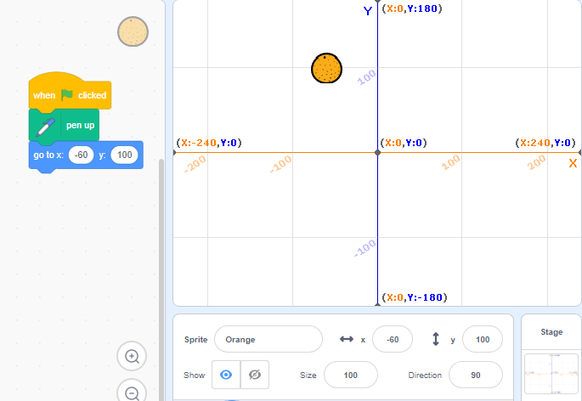 |  | Learners follow instructions provided by the teacher to position spite in XY grid. | Critical thinking enhanced by coding using scratch,  Communication enhanced throug group discussion
Development of the lesson 20 minutes | -Ask learners to draw a line representing the path of the moving position from one point to another.  Demonstration:  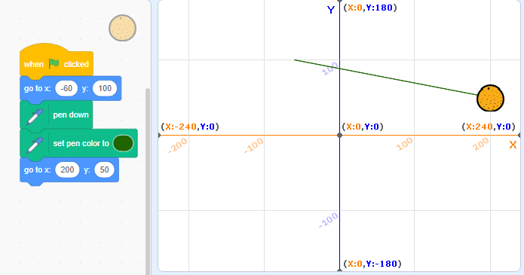  Ask learners to draw a circle from a given position  Demonstration:  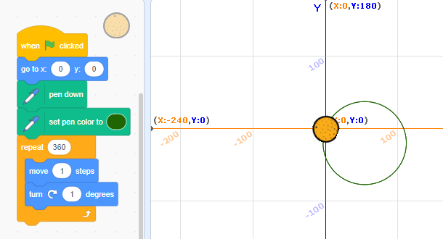  Exercise  Ask learners to position two spite in different location and represent a line joining them. And a circle with |  | -Learners join group for discussion and present their findings.  Discuss about different steps followed to draw a line.  Discuss about different steps followed to draw a circle.  Discuss the difference between circle and straight line. | Help learners slow learners  Critical thinking and cooperation enhanced by coding through scratch and group discussion
Conclusion and evaluation 10 minutes | Guide learners to draw different lines in XY grid |  | Learners draw different lines in XY grid.
Teacher self-evaluation | The lesson is well conducted when the expected outcome are attained

