Biology Senior 2
Unit 3: Passive movement of substances across a cell membrane
Remember:
- Passive movement of substances into and out of cells involves diffusion and osmosis. These processes involve kinetic energy of the molecules involved.
- Diffusion is the movement of particles from an area of higher concentration to one of lower concentration along a concentration gradient. These particles move by their natural kinetic energy.
- A concentration gradient is the difference in solute concentration between two points separated by a distance.
Revision questions
Section A: Multiple choice
- During the diffusion and osmosis:
- Molecules or ions do no move at any direction
- Molecules or ions move randomly at any direction
- Involve kinetic energy of the molecules involved.
- Occur in both living and dead cells
- A solution X is said to be hypertonic than solution Y when:
  - Solution X has high concentration of solute than solution Y
  - Solution X has low concentration of solute than solution Y
  - Solution X has the same concentration of solute as solution Y
  - Solution X has large volume of solvent than solution Y
- Container S contains a 5% salt solution while container T contains a 20% salt solution. If the solutions are separated by a partially permeable membrane; net movement of water will occur from to:
- S to T
- T to S
- Both ways
- None of the above
- Which factor among the following does not influence the rate of diffusion?
  - Concentration gradient
  - The temperature
  - The surface area.
  - The color of the solvent
- Which of the statements below about osmosis is true?
  - Osmosis occurs due to hydrostatic pressure outside the cell.
  - The higher the osmotic pressure of a solution, the greater the tendency of water to move into the solution.
  - The greater the solute concentration, the smaller the osmotic pressure.
  - Osmosis moves water molecules from a greater solute solution to a lesser solute concentration.
Section B: Structured questions
- Complete the following statements:
- _______________________ is the movement of the molecules of gas, liquid or solute from a region of their __________________ to a region of their ____________________ and which results in ______________________ distribution.
- When two solutions are separated from one another by a special selectively ____________________ or semi ________________________ membrane, there is net flow of water molecules from a solution in which water molecules are ___________________ into a solution in which water molecules are ________________________ through the special membrane. This process is known as _____________________. It is described as a special type of diffusion in which _________________ molecules move from a ________________________solution into a ___________________ solution.
- Two potatoes were peeled. One of them was boiled. A cavity was made in each of the potatoes and the experiment was set up as shown below. The experiment was left undisturbed for 24 hours.
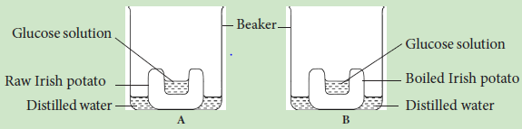
- Draw a diagram to illustrate the result in each figure.
- Give reasons to support your answer in (a) above.
- The following apparatus were set up and the experiment left for hours.
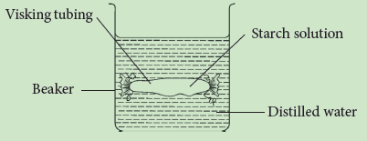
- (i) What observation would you make after one hour?
(ii) Account for your observation in (a) i above.
- (i) If the starch solution was replaced with 10% glucose solution, and the distilled water replaced with iodine solution, what observation would you make?
(ii) Account for your observation in (b) i.

Biology S2
Answers for Unit 3
Section A: Multiple choice
Question | 1 | 2 | 3 | 4 | 5
Answer | C | A | A | D | B

Section B: Structured questions
- Missing words:
Ans/
a) Diffusion, high concentration, low concentration, uniform.
b) Permeable, permeable, more, less, osmosis, water, dilute, Describe the three types of ecological pyramids and give the advantages and disadvantages of each.
- Refer to the diagram below.
Ans/
- Diagrams of A and B
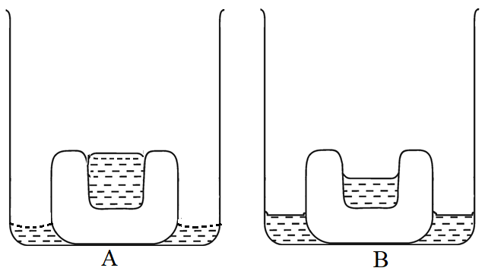
- Osmosis will take pace only in bloc A made of living cells. The sucrose solution in the depression is hypertonic. It develops an osmotic pressure which withdraws water molecules from the beaker and fills the depression. The boiled block is made of dead cells. Therefore. osmosis will not take place. There will be no net movement of water molecules
- Consider the following:
- (i) No observable change occurred.
(ii) Water molecules did not get into the visking tubing because osmosis did not take place (starch is osmotically inactive)
- (i) Brown colour will move from the beaker to glucose solution in the visking tube.
(ii) Glucose is osmotically active hence water molecules containing iodine particles (brown) will get inside the visking tubing. This will turn the colourless glucose solution brown.

