Biology Senior 2
Unit 3: Passive movement of substances across a cell membrane
Remember:
- Passive movement of substances into and out of cells involves diffusion and osmosis. These processes involve kinetic energy of the molecules involved.
- Diffusion is the movement of particles from an area of higher concentration to one of lower concentration along a concentration gradient. These particles move by their natural kinetic energy.
- A concentration gradient is the difference in solute concentration between two points separated by a distance.
Revision questions
Section A: Multiple choice
- During the diffusion and osmosis:
- Molecules or ions do no move at any direction
- Molecules or ions move randomly at any direction
- Involve kinetic energy of the molecules involved.
- Occur in both living and dead cells
- A solution X is said to be hypertonic than solution Y when:
  - Solution X has high concentration of solute than solution Y
  - Solution X has low concentration of solute than solution Y
  - Solution X has the same concentration of solute as solution Y
  - Solution X has large volume of solvent than solution Y
- Container S contains a 5% salt solution while container T contains a 20% salt solution. If the solutions are separated by a partially permeable membrane; net movement of water will occur from to:
- S to T
- T to S
- Both ways
- None of the above
- Which factor among the following does not influence the rate of diffusion?
  - Concentration gradient
  - The temperature
  - The surface area.
  - The color of the solvent
- Which of the statements below about osmosis is true?
  - Osmosis occurs due to hydrostatic pressure outside the cell.
  - The higher the osmotic pressure of a solution, the greater the tendency of water to move into the solution.
  - The greater the solute concentration, the smaller the osmotic pressure.
  - Osmosis moves water molecules from a greater solute solution to a lesser solute concentration.
Section B: Structured questions
- Complete the following statements:
- _______________________ is the movement of the molecules of gas, liquid or solute from a region of their __________________ to a region of their ____________________ and which results in ______________________ distribution.
- When two solutions are separated from one another by a special selectively ____________________ or semi ________________________ membrane, there is net flow of water molecules from a solution in which water molecules are ___________________ into a solution in which water molecules are ________________________ through the special membrane. This process is known as _____________________. It is described as a special type of diffusion in which _________________ molecules move from a ________________________solution into a ___________________ solution.
- Two potatoes were peeled. One of them was boiled. A cavity was made in each of the potatoes and the experiment was set up as shown below. The experiment was left undisturbed for 24 hours.
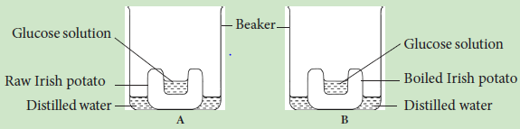
- Draw a diagram to illustrate the result in each figure.
- Give reasons to support your answer in (a) above.
- The following apparatus were set up and the experiment left for hours.
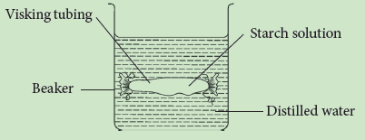
- (i) What observation would you make after one hour?
(ii) Account for your observation in (a) i above.
- (i) If the starch solution was replaced with 10% glucose solution, and the distilled water replaced with iodine solution, what observation would you make?
(ii) Account for your observation in (b) i.

