S 2 PHYSICS EXERCISES TERM1 2020

Unit 1: Sources of errors in measurement ofphysical quantitieS
PART I : M.C ( write a letter corresponds to a right answer)
1.S I unit of length is:
a. Meter per second b. Meter c. Squared meter
2.Unit of mass is
a. Kilogram b. Meter c. Squared meter d. None of the above
3. Device used to measure the diameter of ball bearing is:
a. Spring balance b. Micrometer screw gauge c. meter ruler d. Dynamometer
4.which of the following physical quantities, is not a vector quantity
a. Velocity b. Mass c. Acceleration d. Weight
5. In science, measurement is a process of obtaining:
a. Length of a quantity b. Magnitude of a quantity c. Direction of a quantity d. No answer
6. The most suitable instrument to measure length of a football field is:
a. Meter ruler b.Tape measure c. Vernier caliper c. Micrometer screw gauge
7. which of the following quantities is not a fundamental quantity
a. Time b. luminosity c. Mass d. current e. Speed
8. A measurement is defined as
a. An observation that has numerical value
b. An observation that has a unit
c. An observation and direction
d. observation that has numerical value and unit
9. Systematic error may be due to:
a. Random noise b. Poor instrument c. Incorrectly calibrated scale d. All are correct
10. Accuracy is defined as:
a. The degree of closeness between a measured value and a true value
b. Degree of a measured value
c. Degree of hotness and coldness of a system
d. None of the above
11. Error that occurs due to equally affected measurements is called
a. random error b. systematic error c. frequent error d. precision
12. Zero error is an indication of
a. Instrumental error b. human error c. physica error d. psychological error
13. Which of the following is a dimensional constant?
a. Electrons b. Area c. Specific gravity d. Gravitational constant
14. How many significant figures are in the number 0.00350?
a. 3 b. 5 c. 6 d. 2
15. Which zeros are significant in the number 0.0103
- Only the zero at the end is significant.
- Only the zero between the 1 and 3 is significant.
- The zero between the 1 and 3, and the zero after the 3 is significant.
- All of the zeros are significant.
16. Round off the number 4.35 to 2 significant figures.
a. 4.3 b. 4.4 c. 4.0 d.4.5
17. Rounded to 2 significant figures, 299374 is
a. 29 b. 290000 c. 30 d. 300000

18. Which measurement is most precise?
a. T=7.5s ± 0.1s
b. L =10.0m± 0.2m
c. D=5.6cm± 4%
19. 50. A system will be error free if we remove
a. all systematic error b. mental error c. synthesis error d. None of the above
20. All physical quantities have
a. Dimensions b. Magnitude c. Unit d. Both magnitude and unit
21. Which of the following is NOT true about the standard error of a statistic?
a. The standard error measures, roughly, the average difference between the statistic and the population parameter.
b. The standard error is the estimated standard deviation of the sampling distribution for the statistic.
c. The standard error can never be a negative number.
d. The standard increases as the sample size(s) increases error.
22. The dimensional formula for gravitational constant is;
a. M1L3T–2 b. M–1L3T–2 c. M–1L–3T–2 d. M1L–3T 2
PARTII: STRUCTURED QUESTION
1. Differeniate sysmatic errors from random errors
2. Systematic errors or Constant error are errors due to known reasons. Give and explain with examples the causes of systematic errors and state how the erroes can be minimised.
3. A student was classifying physical quantities and said that Area is a fundamental quantity not a Delivered quantity. Is the student’ classification correct? Explain your answer.
4. If the measurement is 5.2cm and the uncertainty is about 0.1 cm, what is the percentage uncertainty
5.You find the length of the object to be 10.2 cm, with an absolute error of 0.2 cm; the length is reported as (10.2 ± 0.2) cm. Express this error as a percentage of the length:
6. The average life of an Indian is 56 years. Find the number of times the human heart beats in the life of an Indian, if the heat beats once in 0.8 s.:
7. If the unit of force is 1kN; unit of length is 1km and the unit of time is 100s. what will be the unit of mass
ANSWERS
PARTI: M.C
1 | 2 | 3 | 4 | 5 | 6 | 7 | 8 | 9 | 10 | 11
b | a | b | b | b | b | e | d | d | a | b

12 | 13 | 14 | 15 | 16 | 17 | 18 | 19 | 20 | 21 | 22
a | d | b | d | b | d | a | a | d | d | c

PARTII:
1.
Systematic errors | Random errors
- These are errors come from instruments  - After eliminating or reducing systematic error the results obtained said to be accurate | -These are errors came from operation  -After minimizing random error the results obtained is said to be precise
2. The causes of systematic errors are subdivided into 3 categories as below
a. Instrumental error
It is the same error repeated every time in a series of observations.
A common cause of this error is an instrument used.
Example: Scale of instrument badly calibrated
In order to minimize this error, measurements are made by different possible methods and the mean value so obtained is regarded as the true value.
b. Personal errors (or human errors) : they are errors due to individual traits
like:
- Improper setting of the instrument.
- Wrong recordings of the observation.
- Not taking into account sources of error and precautions.
- Usage of wrong values in the calculation.
- using the wrong units
These errors can be minimized only if the observer is very careful in his observations and sincere in his approach.
(c) External errors: they are due to external sources
- These errors can be minimized by identifying or knowing the source of error.
3. The student’ classification is not correct, This is because Fundamental quantities are quantities which cannot be expressed in terms of any other physical quantity while
Derived quantities are quantities that can be expressed in terms of fundamental quantities and $Area=lengthxlenth=l^{2}, Hence Derived quantity$

4. The percentage relative error
is given by
$\frac{0.1}{5.2}x100=2\%$

5. Error as a percentage of the length is given by
$$\frac{∆L}{L}*100=\frac{0.2}{10.2}*100=1.961\%$$
6. Average life of an Indian in seconds = 56 years $56x365.25x24x60x60=1767225600 s$
Period of heart beat = 0.8 s
Total number of heart beats in 56 years $=\frac{1767225600}{0.8}=2.2x{10}^{9} beats$
7. From $F=mxa$
$$M=\frac{F}{a}=\frac{F}{LT^{-2}}=\frac{FT^{2}}{L}=\frac{1000Nx{100}^{2}s^{2}}{1000m}=\frac{1kgm}{{ms}^{2}}x10000s^{2}={10}^{4}kg$$

Unit2: Quantitative analysis of linear motion
PART I: M.C

UNIT 2: QUANTITATIVE ANALYSIS OF LINEAR MOTION

1. Motion on straight line is
a. Circular motion b. Linear motion c. Nonlinear motion d. No one of the above
2. In uniform motion
- The speed of an object remains constant
- The speed of an object change at a constant rate
- The speed of an object increases with a time
- The speed of an object decreases with time
3. Distance is
- the length between two points in particular direction
- the length between two points along the path followed by an object
- the length between too points in shortest way
- no one of the above

4. Displacement is
- the length between two point in particular direction
- the length between point along the path followed by an object
- the length between two point in shortest way
- a and c are correct
5.Displacement is
- vector quantity b. scalar quantity c. derived quantity d. no one of above

6. When a body moves along a curved path then that motion is called
- curvilinear motion
- Linear motion
- Varied motion
- Harmonic motion
7. When a body moves on a straight line without changing its velocity we say that it is in:
- Uniform linear motion
- Uniform curvilinear motion
- Uniform accelerated motion
- Speed governor
8. the SI unit of acceleration is:
- $m/s$
- $m/skg$
- m/s²

9. When the velocity of a body is decreasing, the body is said to be
- Accelerating b. Decelerating
- Free fall d.Uniform
10. When acceleration is constant both in direction and in magnitude, the object is said to be undergoing
- Varied acceleration
- Negative acceleration
- uniformly accelerated motion

11. A motor car is uniformly retarded and brought to rest from a speed of 108 km/h in 15 s. its acceleration is:
- -2ms⁻² b. 2ms⁻² c. 2.5ms⁻² d. 7.2 ms⁻²

12. the graph below represents:
- Uniform acceleration b. Uniform deceleration c. Uniform speed d. None of above
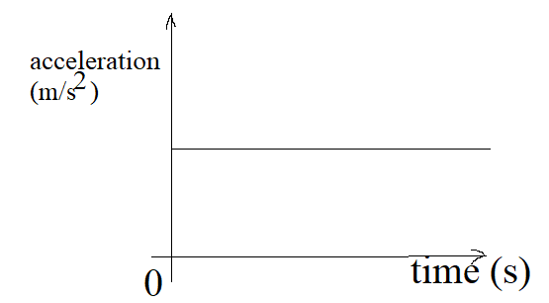
Answer is a

13. The direction of acceleration due to gravity is:
- always downward toward the centre of the Earth
- always upward toward the centre of the Earth
- always horizontal toward the centre of the Earth
14. the magnitude of the acceleration due to gravity is approximately:
- 9.81m/s² b. 8.91m/s² c. 81.9m/s² d. 7.81m/s²
15. If an abject swings as a simple pendulum, Such oscillatory motion is called
- linear motion
- simple harmonic motion
- free fall
- circular motion
16.Distance moved in a stated direction is called
- acceleration b. velocity c. displacement d.motion
17.On a speed-time graph, the steeper the line means
- traveling at a constant speed b. not moving
c. slower the acceleration d. faster the acceleration
18. A ball tossed vertically upward rises, reaches its highest point, and then falls back to its starting point. During this time the acceleration of the ball is always
a. in the direction of motion. b. opposite its velocity.
c.directed downward. d. directed upward.
19.An object is released from rest and falls in the absence of air resistance. Which of the following is true about its motion?
A. Its acceleration is zero
B. Its acceleration is constant
C. Its velocity is constant
D. Its acceleration is increasing
20. The acceleration due to gravity is zero at ……..
  - the equator b. poles c. sea level d. the centre of the earth

PARTII: STRUCTURED QUESTIONS
1. A stone dropped from the roof of a building takes 4 seconds to reach the ground. What is the height of the building?
2. A Cyclist starts from rest and accelerates by 1m/ s² during 20seconds. Then after he travels at a constant velocity during one minute and finally decelerates by 2m/s² Calculate:
a. The cyclist’s maximum velocity
b. Total distance moved by the cyclist
c. Average velocity
3. A plane starting at rest at one of a runway undergoes a constant acceleration 4.8 m/s² for 20 s before takeoff.
- What is its speed at the takeoff?
- How long must be the runway for the plane to be able to takeoff?
4) How fast different objects fall in the absence of air resistance.
5) A stone dropped from the top of a building takes 5 seconds to reach the ground.
- a)What is the height of the building?
- What will be its velocity just before hitting the ground?
6. When a golfer hits a ball his club is in contact with the ball for about 0.0005 s and the ball leaves the club with a speed of 70 m s⁻¹. The mass of the ball is 46 g.
a Determine the mean accelerating force.
b What mass, resting on the ball, would exert the same force as in a?
7. The cyclist in the Figure below is travelling at 15 m s⁻¹. She brakes so that she doesn’t collide with the wall. Calculate the magnitude of her deceleration.
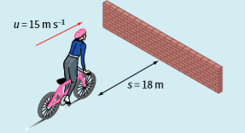

8. The graph in Figure below represents the motion of an object moving with varying acceleration. Lay your ruler on the diagram so that it is tangential to the graph at point P.
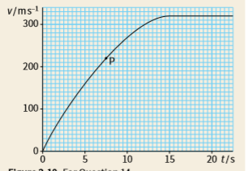
a What are the values of time and velocity at this point?
b Estimate the object’s acceleration at this point
9. The velocity–time graph below represents the motion of a car along a straight road for a period of 30 s.
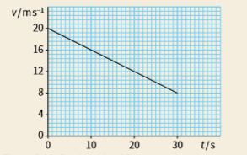
a Describe the motion of the car.
b From the graph, determine the car’s initial and final velocities over the time of 30 s.
c Determine the acceleration of the car.
d By calculating the area under the graph, determine the displacement of the car.
10. A boy stands on a cliff edge and throws a stone vertically upwards at time t = 0. The stone leaves his hand at 20 m s⁻¹. Take the acceleration of the ball as 9.81 m s⁻².
a Show that the equation for the displacement of the ball is: s = 20t − 4.9t²
b What is the height of the stone 2.0 s aft er release and 6.0 s aft er release?
c When does the stone return to the level of the boy’s hand? Assume the boy’s hand does not move vertically after the ball is released.
11. In an experiment to determine the acceleration due to gravity, a ball was timed electronically as it fell from rest through a height h. The times t shown in Table below were obtained.
Height in meters | 0.7 | 1.03 | 1.25 | 1.60 | 1.99`
Time in sec | 0.99 | 1.13 | 1.28 | 1.42 | 1.60

a . Plot a graph of h against t².
b From the graph, determine the acceleration of free fall, g.
c Comment on your answer
ANSWERS
PART I: M.C
1 | 2 | 3 | 4 | 5 | 6 | 7 | 8 | 9 | 10 | 11 | 12 | 13 | 14 | 15 | 16 | 17 | 18 | 19 | 20
b | a | b | d | a | a | a | c | b | c | a | a | a | a | b | c | d | c | b | d

PART II: STRUCURED QUESTIONS

1. The initial velocity u=0m/s $From H =ut+\frac{1}{2}gt^{2}=0x4+\frac{1}{2}x9.8x4^{2}=78.4m$
2. a. $V=u+at=0+1x20=20m/s$
b.
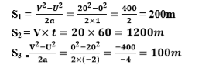
Therefore .$Total distance=200m+1200m+100m=150m$
c.
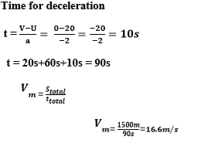
3. a. v = at = 4.8x20 = 96 m/s.
b) .The runway must have more than 960 m.
4. All objects dropped near the Earth’s surface fall toward the Earth with the same constant acceleration due to Earth’s gravity.
5. a)
b)
6. a .average acceleration$a=\frac{∆v }{∆t}=\frac{70}{0.0005}=140x{10}^{3}ms^{-2}$
average force $F=mxa=14000x 0.046=6440N$
b .$From W=mg → m=\frac{W}{g}=\frac{6440 }{9.8}=660 kg$
7. $From v^{2}= u^{2}+2as i.e a=\frac{v^{2}- u^{2}}{2s}=\frac{0^{2}-{15}^{2}}{2x18}= -6.25 ms^{-2}$
8. a. t = 7.5 s and v = 220 m s^{–1}
b. Draw a tangent to the curve at point P. Read off two sets of values from the tangent to find the gradient. For example: at time t₁ = 0 s, v1 ≈ 60 m s^{–1}
at time t₂ = 12 s, v2 ≈ 300 m s^{–1}
Approximate acceleration $a=\frac{∆v}{∆t}=\frac{300-60 }{12-0}=\frac{240}{12}=20ms^{-2}$
9. a The car is slowing down with constant (uniform) deceleration.
b Initial velocity v₁ = 20 m s^{–1} and final velocity v₂ = 8 m s^{–1}
Acceleratio $a=\frac{∆v}{∆t}=\frac{8-20 }{30-0}=\frac{-12}{30}=-0. 4ms^{-2}$
d. Displacement of car = area under graph
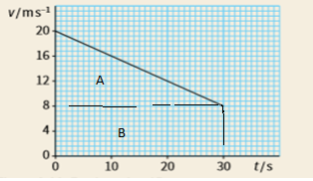
Area under the graph is given by $D=area of A+area of B$
$D=\left(8X30\right)+\frac{1}{2}x12x30=420m$
10.
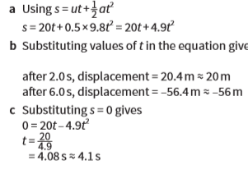
11. a. Complete the graph first
Height in meters | 0.7 | 1.03 | 1.25 | 1.60 | 1.99`
Time in sec | 0.99 | 1.13 | 1.28 | 1.42 | 1.60
Square time | 0.98 | 1.28 | 1.64 | 2.02 | 2.56

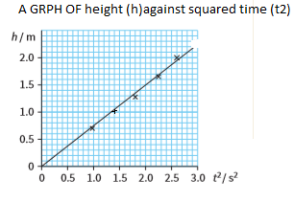
b. $From S=\frac{1}{2}gt^{2}. this shows that slope s=\frac{1}{2}g i.e g=2xslope$
$$slope=\frac{∆h}{∆t^{2}}=\frac{1.99-0.7}{2.56-0.98}=\frac{1.29}{1.58}=0.816ms^{-2}$$
$$Then g=0.816ms^{-2}x2=1.6ms^{-2}$$

c. This object is not falling on the Earth, perhaps on the Moon.

Unit 3: Friction Forces

PARTI: M.C
- In the following definition, choose the correct definition of friction
- The friction force is the force exerted by a surface as an object moves across it or makes an effort to move across it
- Friction is a force which tends to oppose the motion of a moving object in space
- Friction force is a force that the earth has to attract the objects
- Friction force is s force of attraction and repulsion of a magnet

- Friction occur:
- Between two sliding surface
- Between two contact surface
- Between two cars

- The frictional force is directly related to the
- normal force
- mortice force
- weight
- acceleration

- the coefficient of sliding friction between the two surfaces depends on
- the roughness of the surfaces
- the area of the surface
- the elevation of the surface

- the following are the advantages of friction force except.
- Friction tends to generate heat energy
- Friction reduces the speed of moving objects and therefore causes loss of energy
- Friction damages sliding surfaces that are in contact
- Friction causes wear and tear in moving parts
- Friction increase the speed of a moving object

- The following forces are example of resistance force except
- Air resistance
- Tension force
- Electric force
- Friction force
- Four children were asked to arrange forces due to rolling, static and sliding frictions in a decreasing order. Their arrangements are given below. Choose the correct arrangement
- rolling, static, sliding
- rolling, sliding, static
- static, sliding, rolling
- sliding, static, rolling

- A force that always acts to oppose motion
- Mass
- Force
- Friction force
- Acceleration
- Which surface has the least amount of friction?
- Ice b. Grass c. Concrete

- When a certain force is applied to an object with a mass of 2 kg, its acceleration is 10.0 m/s². When the same force is applied to a different object, its acceleration is 4.0 m/s². The mass of second object is

- 10.2 kg
- 8.0 kg
- 5.0 kg
- No best answer

- The tension in a string from which a 4.0kg object is suspended in an elevator is equal to 44 N. What is the acceleration of the elevator?

a.11 m/s2 upward
b.1.2 m/s2 upward
c.1.2 m/s2 downward
d.10 m/s2 upward
- The coefficient of kinetic friction is the coefficient of static friction.
- Less than
- Greater than
- Equal to
- All are true
- Friction can be increased by
a) Using air cushion
b) Lubricants
c) Using sand
d) Using ball bearings
- The force of friction acts in a direction …….to the direction of motion of object.
  - Same
  - Opposite
  - Perpendicular
  - Downwards

15. The force of friction depends upon
  - Nature of surface of contact
  - Material of objects in contact
  - Both ‘a’ and ‘b’
  - None of the above
16. The body will move only when
a. Force of friction equal to applied force
b. Force of friction is less than applied force
c. Force of friction is greater than applied force
d. All of the above

17. Friction offers by a slippery ground is
  - very high b. very little c. very difficult d. circular

18. When a force applied on an object, it can
  - speed up the object
  - slow down the object
  - stop an object
  - all of them
19. Friction between moving parts of machine produces
  - heat
  - light
  - energy
  - oil
20. If after a slight tilt body returns to its previous equilibrium, then it is said to be in
- zero equilibrium
- stable equilbrium
- unstable equilibrium
- neutral equilibrium

21. ………………. friction is the force of friction experienced by a body when it is at rest.
- Dynamic
- Static
- Sliding
- Rolling
22. What kind of friction occurs when solid surfaces slide over each other?
- Static friction
- Sliding friction
- Rolling friction
- Fluid friction

PARTII: STRUCTURED QUESTIONS
1. a. Differentiate solid friction force from fluid friction force
b. State the factors affecting friction force.
c. How friction can reduced?
2. a. Explain why athletes use shoes with spikes.
b. Explain why objects moving in fluids must have special shapes
3. Two Spherical metal block of the same mass are dropped at the same time in two different containers of petrol and oil respectively. In which liquid do you think the metal block reach the bottom first and why?
4. What is the smallest value of the friction force such that the 2.0-kg block will not slide down the wall? The coefficient of static friction between the block and the wall is 0.2.
5. A 30.0-kg person slides on a frictionless 20° inclined plane. A force of 160 N acting parallel to the incline and up the incline is applied to the man as indicated below.
What is the acceleration of the man?

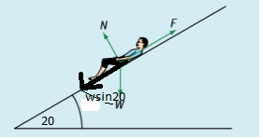

.
6. Consider the car diagram below. Name the different forces represented by the arrows F1, F2, F3, F4 and F5 on the diagram.
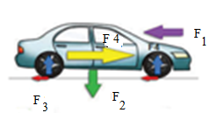
7. A person applies a 9.0 N rightward force to a 0.5 kg book to accelerate it across a table top. The coefficient of friction between the book and the table top is 0.410. Determine the acceleration of the book (take g=10 m/s²).
8. A 2.50 kg block is resting on a horizontal surface. The coefficient of static friction between the surfaces in contact is 0.350. Calculate the maximum magnitude of force of static friction between the surfaces in contact.
9. A 10 kg box on a horizontal table is pushed by a horizontal force of 38 N as shown below. If the coefficient of friction is 0.4, will the box move? Explain your answer
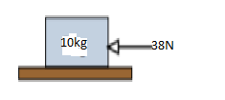
10. Describe the factors affecting the friction force

ANSWERS
PARTI: M.C
1 | 2 | 3 | 4 | 5 | 6 | 7 | 8 | 9 | 10 | 11 | 12
a | a | a | a | e | c | b | c | c | c | a | a

13 | 14 | 15 | 16 | 17 | 18 | 19 | 20 | 21 | 22
c | b | c | b | b | d | a | b | b | b

PARTII: STRUCTURED QUESTIONS
1. a. Friction force is a force that opposes relative sliding motion of two surfaces of objects in contact while Fluid friction force is the friction due to the viscosity, where Viscosity is a measure of how easily a fluid flows.
b- Nature of the surfaces
-Force pressing the surfaces together,
-Type of shape and speed of the moving object.
c. We can reduce the friction by making the surface smooth; using lubricants or roller and bearings.
2. a. Athletes uses shoes with spikes because spikes reduce friction between the feet of athletes and the ground.
b. Objects moving in fluids must have special shapes in order to reduce the fluid resistance which opposes the motion of the objects.
3. The spherical metal block will reach the bottom first in petrol tank. This is because Oil has high viscosity than Petrol.
4. The smallest Fr $F=μR=μmg=0.2x2x9.8=3.92N$

5. The acceleration will pull the man on the plane
There fore $From F=mxa i.e a=\frac{F}{m}=\frac{160}{30sin20}=5.84ms^{-2}$

6. F1 is air resistance; F2 is weight of the car; F3 is friction; F4 is reaction force and F5 is driving force.
7.
and
8. $F=μR=μmg=0.350x 2.50x10=8.75N$
9. $Maximum pssible friction force F=μR=μmg=0.4x10x9.8=39.2N$
The pushing force, 38N, is less than Friction, Therefore the box will not move.
10. a. Adhesion: This is a property of sticking together (as glue and wood) or the joining surfaces of different composition.
The opposite of adhesion is cohesion.
Cohesion is a property of sticking together (as oxygen O₂) or the joining surfaces of same composition.
b. Smoothness: is a property of being smooth of a given surface.
c. Area of the contact with the surfaces:
The higher the area of contact the higher the friction force it is.
d. Weight of the object: The higher the weight of an object the higher the friction force it is.

UNIT4: DENSITY, PRESSURE IN SOLIDS AND FLUID
PART I: M.C
UNIT 4: DENSITY AND PRESSURE IN SOLIDS AND FLUID
BEGINNERS

- Pressure is defined as:
- the force acting normally per unit area applied in a direction perpendicular to the surface of an object
- the force acting normally on area applied in a direction perpendicular to the surface of an object
- the force acting normally on area applied in a direction perpendicular to the surface of an object
- a and b are correct
- If the force is concentrated on a small area, it will exert
- higher pressure than if the same force is distributed over a larger surface area
- lower pressure than if the same force is distributed over a larger surface area
- same pressure than if the same force is distributed over a larger surface area
- all are true
- which of the following is an instrument used to measure force (weight) is:
- spring balance
- beam balance
- stop watch
- meter ruler
- Mathematical terms, pressure can be expressed as:
- $P=\frac{A}{F}$
- $P=\frac{m}{A}$
- $P=\frac{F}{A}$
- $P=m.a$
- To measure Pressure in liquids We use:
- Manometer
- Barometer
- Forcemeter
- All are true
- The Pascal’s law is applicable to the liquid which is __________________
a) Compressible
b) In-compressible
c) Solid in phase
d) Super-compressive
- Mass is a measure of
- Weight B. inertia C. friction D.matter
- Density of a ship should be …………density of water
- Less than
- Greater than
- Equal to
- None of the above

- Liquid water is more dense than ice because
  - when ice melts there is an increase in the amount of molecules
  - a chemical change occurs as ice melts that causes the mass of the water to increase
  - the volume of the liquid increases when it freezes
  - liquid water molecules have more mass than ice molecules
- Two liquids, A and B, have densities 0.75 g/mL and 1.14 g/mL respectively. When both liquids are poured into a container, which liquid floats on top?
  - neither; they mix evenly
  - A
  - both; they keep trading places like a lava lamp
  - B

- If a metallic sphere is heated which of the following is most likely to occur?
  - the volume of the sphere will decrease but its density will increase
  - both the volume and the density will decrease
  - both the volume and the density will increase
  - the volume of the sphere will increase but its density will decrease
- Which characteristic of an object will always change as the object travels from the Earth to the Moon?
  - Weight
  - Mass
  - Volume
  - Density
- Oil floats on water. The most accurate reason for this is
  - oil is both less dense and immiscible with water
  - oil is immiscible (does not dissolve) in water
  - oil is less dense than water
  - water is heavier than oil
- The pressure at any given point of a non-moving fluid is called the
a) Gauge Pressure
b) Atmospheric Pressure
c) Differential Pressure
d) Hydrostatic Pressure
- What type of liquids are measured using a manometer?
a) Heavy liquids
b) Medium Liquids
c) Light Liquids
d) Heavy and light liquids

- Earth is surrounded by a cover of air called
- Gravity B. energy C. ozone D. atmosphere
- Amount of pressure of liquid increases with
- Volume B.base area C. mass D. depth
- The pressure on a submerged object acts
  - Only on the top surface of the object.
  - Perpendicularly on every section of the submerged object.
  - Only on the bottom surface of the object.
  - On the top and the sides of the submerged object.

- As the amount of moisture in the air increases the air pressure
      - increases
      - decreases
      - stays the same
      - doesn't change
- Cold air exerts ……………… pressure than warm air.
- the same
- less
- more
- You use a ___________ to measure air pressure.
- anemometer
- wind vane
- barometer
- phychrometer
- As altitude increases, air pressure
        - increases
        - decreases
        - stays the same
        - doesn't change

- What is the purpose of having cylindrical water towers above ground or water tanks at the top of buildings?
- To increase the height of the water column, thereby increasing the water pressure in homes and apartments.
- To increase the volume of water, thereby increasing the water pressure in homes and apartments.
- To displace water so less water is placed behind large dams in reservoirs.
- To store water for use by consumers.

- Hydrostatic pressure variation implies that :
- the pressure varies linearly with depth
- the piezo metric head is constant
- the density of the fluid is constant
- pressure varies linearly with distance
PART II: STRUCTURED QUESTIONS
1. a.Define the term pressure and give its S.I unit
b. A table stands on four feet, each of area 20 cm². The table holds a box of 50N and the weight of the table is 80 N. Calculate the pressure it exerts on the floor.
2. Mass of oil is 11040 kg and volume is 124 m³. Determine its density and Relative density
3. The mass of a substance is 500 g and its density is 800 kg/m³.Calculate the volume of the substance and expresses the answer in cm³
4. Acylindrical metal has a diameter of 28cm and a height of 10cm. Determine its density is 9g/cm³. ( Use $π=\frac{22}{7}$ )
5. The mass of the rectangular block below is 16kg. Calculate the difference between maximum and minimum pressure exerted on the ground by the block. Take g = 10N/Kg

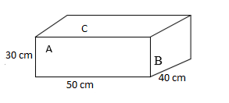
6. a. Express the pressure of 760mmHg in Pascals. (use)
b. If water poured in a cylinder container with three small holes A, B and on the sides on which water can pass through. Explain why water at hole A travelled a long distance than other holes.
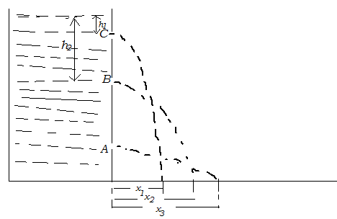
7. a. Why do trucks have large tyres
8. a. why water supply reservoir are often put on high hills or mountains
b. The pressure in water pipe at a mouth of tap is 5 x10³ Pa. what is the height of the water pipe? g = 10m/S² and the density of water 1000kg/m³
9. The atmospheric pressure reading on the base of a mountain is 740mmHg. The atmospheric pressure reading on the top of mountain is 600mmHg. Calculate the height of mountain. Use density of mercury 13600Kg/m³ and density of air is 1.26Kg/m³

ANSWERS

PART I: M.C
1 | 2 | 3 | 4 | 5 | 6 | 7 | 8 | 9 | 10 | 11 | 12
a | a | a | c | a | b | d | a | d | b | b | a

13 | 14 | 15 | 16 | 17 | 18 | 19 | 20 | 21 | 22 | 23 | 24
a | d | c | c | d | b | a | c | c | b | a | a

PART II: STRUCTURED QUESTIONS

1. a Pressure is the magnitude of a force exerted perpendicular to a given surface of area. Its S.I unit is Pascal (Pa) or 1N/m²
b. $Total area of contact surface=4x20=80m^{2}=0.008m^{2}$
$$Total force exerted=50N+80N=130N$$
2. $ρ=\frac{m}{V}=\frac{11040}{124}=89.0kgm^{-3}$

$$Relative density=\frac{Density of a substance}{Density of water}= \frac{89.0kgm^{-3}}{1000kgm^{-3}}=0.089$$

3. $Since Volume=\frac{m}{ρ}=\frac{500}{800x{10}^{-6}}=625{cm}^{3}$
4. $Since r=\frac{D}{2}=\frac{28}{2}=14cm$
$$Volume of the metal V= πr^{2}h=\frac{22}{7} x{14}^{2}x10=6160 {cm}^{3}$$
$$m=ρxV=9x6160=55440g=55.44kg$$

5. $Maximum pressure exerted by a small area B=30cm x40cm=1200{cm}^{2}=0.12m^{2}$
$$P_{max}=\frac{F}{A_{min}}=\frac{16x10}{0.12}=1333.3 Pa$$
$$Minimum pressure exerted by big area C =50cm x40cm=2000{cm}^{2}=0.2m^{2}$$
$$P_{min}=\frac{F}{A_{max}}=\frac{16x10}{0.2}=800 Pa$$
$$Pressure difference=1333.3-800=533.3Pa$$
6. a. From $P=ρxgxh=13600kgm^{-3}x\frac{760}{1000}x9.81=101292.8 pa$
b. Water from hole A travels a long distance X₃, because Hole A is at a great distance hence indicates high pressure compared to other holes.
7. Trucks have large tyres in order to spread the load over a large surface and reduce the pressure on the ground. Hence less likely to sink in soft ground.
8 a. The t water supply reservoir are often made on high height or high hill or mountain in order to increase its pressure and its potential energy then water flows easily and quickly in all directions because if height increase pressure and potential energy increase
b. $Given P= 5 x{10}^{3} Pa$
$$From P=ρxgxh → h=\frac{P}{ρxg}=\frac{5x{10}^{3}}{1000x10}= 0.5m$$
9. $$Pressure at the base:P=ρxgxh=13600x10x0.74=100640 Pa$$

$$Pressure at the bottom:P=ρxgxh=13600x10x0.6=81600 Pa$$
$$Pressure difference=100640-81600=19040 Pa$$

$$h=\frac{P}{ρxg}=\frac{19040}{1.26x10}= 1511m$$

UNIT 5: APPLICATION OF PASCAL’S PRINCIPLE

PART I: M.C

    - Due to Pascal law, liquid at rest applies …….pressure at any point In all directions.
a) Same
b) Un-same
c) Not matching
d) Matching but not equal
    - The magnitude of the pressure of any fluid depend on the…….
a) Force
b) Area
c) depth
d) Temperature
    - Gases are described as ……. fluids.
a) Compressible
b) In-compressible
c) Solid in phase
d) all are correct
    - What is a collinear system of forces for the system of the fluid liquids?
a) The force system having all the forces parallel to each other
b) The force system having all the forces perpendicular to each other
c) The force system having all the forces emerging from a single point
d) Forces cannot form a collinear system of forces, it is not possible
5. A In a stationary fluid, how does the local pressure of the fluid vary?
a) With depth only
b) In the horizontal direction only
c) Both with depth and along horizontal direction
d) Neither with depth nor along horizontal direction
6. A U-tube manometer is used to measure the pressure of a
(a) Gas
(b) Liquid
(c) Gas as well as liquid
(d) None
7. A Bourdon tube pressure gauge measures
(a) Low pressures
(b) High pressures
(c) Low as well as high pressures
(d) None
8. When you rub your hands together vigorously, the temperature of your skin increases because sliding friction
a. Converts the work you do in sliding your hands across one another to thermal energy in your skin.
b. Prevents convection and conduction from removing heat from the skin of your hands.
c.Transfers heat from your shoulders and arms to the skin on your hands.
d. Causes moisture to condense on your skin and to release its latent heat of vaporization as thermal energy.
9. What is the pressure in Pascal’s at a depth of 1m below the water surface?
a) 9800 Pa b. 980 Pa c. 98 Pa d. 1 Pa
10. The pressure at any given point of a non-moving fluid is called the……..
a) Gauge Pressure
b) Atmospheric Pressure
c) Differential Pressure
d) Hydrostatic Pressure
11. Viscosity can be defined as
a) Resistance to flow of an object
b) Resistance to flow of air
c) Resistance to flow of fluid
d) Resistance to flow of heat
12. If an open tank full of water. The pressure at the bottom of the tank is given by
- Pressure of water only
- Atmospheric pressure only
- Both atmospheric and pressure water
- All of the above
12. The buoyancy of an object is
- The relationship between the object's density to the density of the fluid in which it is submerged.
- The relationship between the object's weight to the density of the fluid in which it is submerged.
- The relationship between the object's mass to the density of the fluid in which it is submerged.
- A and b are correct

PART II: STRUCTURED QUESTIONS
1. State the Pascal’s principle and give at least two applications of it.
2. If in a hydraulic lift, one of the areas of piston is three times larger than the other and the force applied to the smaller area A₂ is F₂ = 15N. Determine the force F₁ measured at the larger area piston.
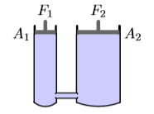
3.In a car lift used in a service station, compressed air exerts a force on a small piston that has a circular cross section and a radius of 5.00 cm. This pressure is transmitted by a liquid to a piston that has a radius of 15.0 cm. What force must the compressed air exert to lift a car weighing13 300 N? What air pressure produces this force?
4. If a force F₁ = 100N is applied on the left in the hydraulic lift shown,
where A₁ = 0.02m² and A₂ = 0.08m², what force F₂ will be produced?
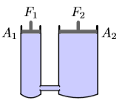
Since the pressure exerted by the force F₁, on the left, is transmitted by the liquid through to the other piston, we have
5. In hydraulic press a force of 2 0N is applied to a piston of area 0.4m² the area of other pistons is 2.5 m^{2.} Calculate:
a) The pressure transmitted through the liquid
b) The force on the other piston
6. A hydraulic press has a larger piston of radius 40cm and a circular plunger of radius 20 cm. A force of 200 N is exerted by the plunger
i) Find the force exerted on the piston
ii) State one reason why the weight of the road just raised by the piston is less than the force obtained
7. When the brake pedal of the car is pressed hard, a force of 900N is applied on the master piston of area 100cm². The pressure is transferred by oil from the master piston to a brake pad operated by a slave piston of area 500cm². Calculate:
(a) The pressure on the master piston.
(b) Force on the slave piston (neglect the force of friction).
8. Water and oil are poured into the U-shaped tube (see figure below) open at both ends, and do not mix. They come to equilibrium as shown in the fig. below. What is the density of the oil?
- 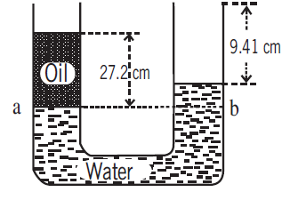
ANSWERS
PART I: M.C
1 | 2 | 3 | 4 | 5 | 6 | 7 | 8 | 9 | 10 | 11 | 12 | 13
a | c | a | a | a | a | c | a | a | d | c | c | a
PART II : STRUCTURED QUESTION
1. Pascal’s principle states that a change in the pressure applied to a fluid is transmitted undiminished to every point of the fluid and to the walls of the container.
Applications
a. - Hydraulic lift
b. Hydraulic Brakes
2. Given that $A_{1}=3A_{2}$ $\frac{F_{2}}{A_{2}}= \frac{F_{1}}{A_{1}} → F_{1}= \frac{F_{2}}{A_{2}}x A_{1}=\frac{F_{2}}{A_{2}}x3 A_{2} i.e F_{1}=3F_{2}$
There for the force $F_{1}=3x15N=45N$
3. Because the pressure exerted by the compressed air istransmitted undiminished throughout the liquid, Then we get

The air pressure that produces this force is
4. $A_{2}$ $\frac{F_{2}}{A_{2}}= \frac{F_{1}}{A_{1}} → F_{2}= \frac{F_{1}}{A_{1}}x A_{2}=\frac{100}{0.02}x0.08=400N$

5. a. From $P=\frac{F}{A}=\frac{20}{0.4}=50Pa$
b. Since pressure is constant at any point $F=PxA=50x2.5=125N$
6. a. Given that $A_{1}= πr^{2}=20x20xπ= 400π$
$$A_{2}= πr^{2}=40x40xπ= 1600π$$
$$\frac{F_{2}}{A_{2}}= \frac{F_{1}}{A_{1}} → F_{2}= \frac{F_{1}}{A_{1}}x A_{2}=\frac{200}{400π}x1600π=800N$$
b. Then load raised by piston is much less than effort due topresence of friction force
7. $Given that A_{1}=100{cm}^{2}=0.01m^{2} and A_{1}=500{cm}^{2}=0.05m^{2}$
$$P_{1}= \frac{F_{1}}{A_{1}}=\frac{900}{0.01m^{2}}=90000Pa$$
$$\frac{F_{2}}{A_{2}}= \frac{F_{1}}{A_{1}} → F_{2}= \frac{F_{1}}{A_{1}}x A_{2}=\frac{900}{0.01}x0.05=4500N$$
8.

UNIT6: MEASUREMENT LIQUIDPRESSURE WITH MONOMETER AND BAROMETER
1. a. what is barometer?
b. With a help of a diagram describe mercury barometer and explain how it is used in measuring liquid pressure.
2. On a certain day a barometer reads 750mm of mercury (750mmHg).
Calculate the pressure in Pascals.

3. On a certain day the atmospheric pressure was 104000Pa. Express this pressure in mmHg.
4. The diagram below indicates one of the instrument used to measure fluid pressure. Name the instrument and briefly describe its main parts
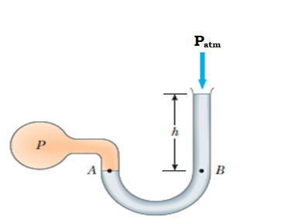
5. Define the term surface tension and outline its daily applications
6. Describe an experiment to show that pressure at a point in a liquid is independent of the shape of the container.
7. The figure below shows an inclined U-tube mercury manometer. The vertical end of the tube is exposed to a gas of gauge pressure 50 kPa and the inclined end is exposed to the atmosphere. The inclined part of the tube is at an angle of 30º with the horizontal. Find the value of h (in cm) (take g = 9.8 m/s², ρ_{mercury} = 13600 kg/m³)
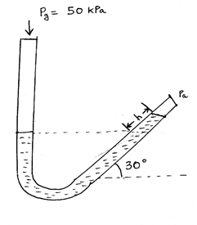
9. In the manometer below, 2 immiscible fluids mercury (ρ = 13600 kg/m³) and water (ρ = 1000 kg/m³) are used as manometric fluids. The water end is exposed to atmosphere (100 kPa) and the mercury end is exposed to a gas. At this position, the interface between the fluids is at the bottom most point of the manometer. Ignore the width of the manometer tube and the radius of curvature. The value of h was found to be 9.45 m. The height of the mercury column is given to be 75 cm. Find the gauge pressure of the gas. (g = 9.8 m/s²)
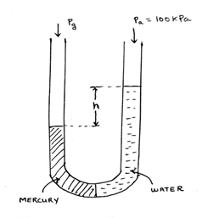

ANSWERS
1. Barometer is an instrument used to measure atmospheric pressure.
b. Mercury barometer is made up of a tube of about 1 m long filled with mercury of density 13,600 kg m^{–3}
It is placed it vertically inverted in a mercury tub as shown is Fig. below.

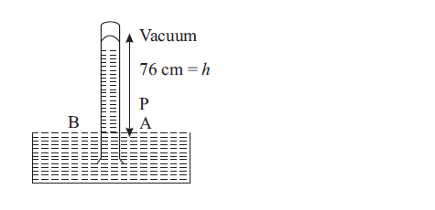
It has a column of 76 cm of mercury above the free surface remained filled in the tube.
In equi1ibrium, atmospheric pressure equals the pressure exerted by the mercury column. Therefore, atmospheric pressure
where is the density of the mercury and h is the height of the mercury column. Giving
2. From
3. From
4. The instrument shown above is called Manometer and is used to measure fluid pressure.
Manometer has One end of a U-shaped tube containing a liquid is open to the atmosphere (P_{atm}), and the other end is connected to a system of unknown pressure P. The pressure at point B equals where is the density of the fluid is. The pressure at B, however, equals the pressure at A, which is also the unknown pressure P.
We conclude that
The pressure P is called the absolute pressure, and is called the gauge pressure.

5. Surface tension is the property of the free surface of a liquid at rest to behave like a stretched membrane in order to acquire minimum surface area.
Applications of surface tension
a. Surface tension impacts and gives early morning dew drops their spherical shape because the moisture in the atmosphere condenses on the beads and leaves due to surface tension.
b. The mercury used in the thermometer does not stick to the wall of the tube because of the surface tension, if it did the measurement of the temperature wouldn't be correct.
c. The separation of oil and water is also caused by the difference in the surface tension of the two liquids.
d. Water insects are able to walk water because of the wax secreted on their legs combined with surface tension's elastic-like cover.
6. When water poured in a connecting vessel of different branches with different shapes, water in different branches will attain the same level regardless of the shape as indicated in the diagram below.
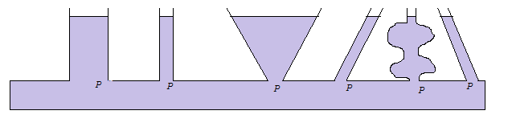
The levels of water in all branches are the same because the pressure in liquid at rest depends only on the depth and the density of the liquid but not the shape of the vessel.
7. The perpendicular height$=hsinθ=hsin30=0.5$
From the diagram $The pressure along the dotted line is 50 kPa$
$$Gauge pressure at angle in an inclined manometer P=ρxgxhsinθ$$
$$50000Pa=13600x9.8xhsin30 →h=\frac{50000}{13600x9xsin30}=\frac{50000 }{66640}=0.75m=75cm$$
9. $$Height of the water column=0.75m+9.45m=10.2m$$
$$Water Pressure at the bottom=Pa+ρ_{w}xgxh$$
$$Mercury pressure at the bottom=Pg+ρ_{m}xgxh$$
$$Equating the pressures at the bottom we get$$
$$Pa+ρ_{w}xgxh= Pg+ρ_{m}xgxh$$
$$100000+1000x9.8x10.2= Pg+13600x9.8x0.75$$

$$199960= Pg+99960 → P_{g}=100kPa=absolute pressure$$
Therefore the $gauge pressure= Pg- Pa=100kPa-100kPa=0Pa$

