BASIC ICT READINESS OBSERVATION CHECKLIST & EVALUATION REPORT
Name of test taker: …………………………………………………………… Assessor: …………………………………………..
School: ………………………………………………………………………………. Date: ……………………………………………..
Task ID | Task | ✓ | ✗ | Comments
A1. Basic Operations
 | Connect devices to the appropriate power outlet.
 | Start up a computer system.
 | Insert a USB memory stick into USB port and access a specified folder
 | Safely dismount a USB memory stick from a computer
A2. File and folder management
 | Create a specified sub-folder
 | Open a specified folder
 | Rename a file
A3. Navigating web-based resources
 | Activate a web page from a specified HTML file
 | Use a pointing device (mouse or touchpad) to navigate a web interface
 | Select a specified tab or menu option on a web interface
 | Activate a hyperlink
 | Download and save a document from a hyperlink
 | Perform a password protected 'Login'
A4. Document Creation
 | Create a new document in a word processor
 | Retrieve a document from a specified place
 | Copy text from a web page and save to document WITHOUT formatting
 | Copy and paste text between documents
 | Save a document in a specified place
A5. Working with e-mail
 | Retrieve an email
 | Download an attachment
 | Compose an email to specified addresses
 | Attach specified documents to an email
 | Send an email

B. Observations
C. Evaluation
D. Recommendations

E. Certifying Statements

I certify that I administered this Basic Readiness Assessment.
……………………………………………………… ……………………………………………. ………………………………….
PRINT NAME Signature Date
I have reviewed the observations recorded on page 1 and am in agreement.
……………………………………………………… ……………………………………………. ………………………………….
PRINT NAME Signature Date
I have discussed the observations, evaluation and recommendation(s) with the teacher.
……………………………………………………… ……………………………………………. ………………………………….
PRINT NAME Signature Date

Guide for Principals and Assessors
Introduction
There is broad consensus on the need for information and communications technology literacy among teachers. We will not succeed by merely providing access to equipment; we must also provide the intellectual tools to use technology effectively, in school and in the workplace. The International Society for Technology in Education (ISTE) has identified 14 necessary conditions to effectively leverage technology for learning. One of these essential conditions is educators, support staff, and other leaders skilled in the selection and effective use of appropriate ICT resources. The provision of competency-based training based on UNESCO’s ICT Competency Framework for Teachers in an avenue that will seek to fulfil this necessary condition.

In many small island states, there is a relative dearth of evidence-based data to isolate exactly what proficiency gaps exist, or what measures to take to ensure that educators enrolling for courses are prepared to engage with the materials for the complexities of an information driven society.

The Basic ICT Readiness Assessment (BIRA) is designed to measure basic readiness of educators to undertake a programme of facilitator-led studies via distance.

Flowchart for Readiness Assessment
The flowchart for readiness assessment provides the sequence of steps to be followed when seeking to determine the readiness of a teacher for enrolment in the Technology Literacy course.

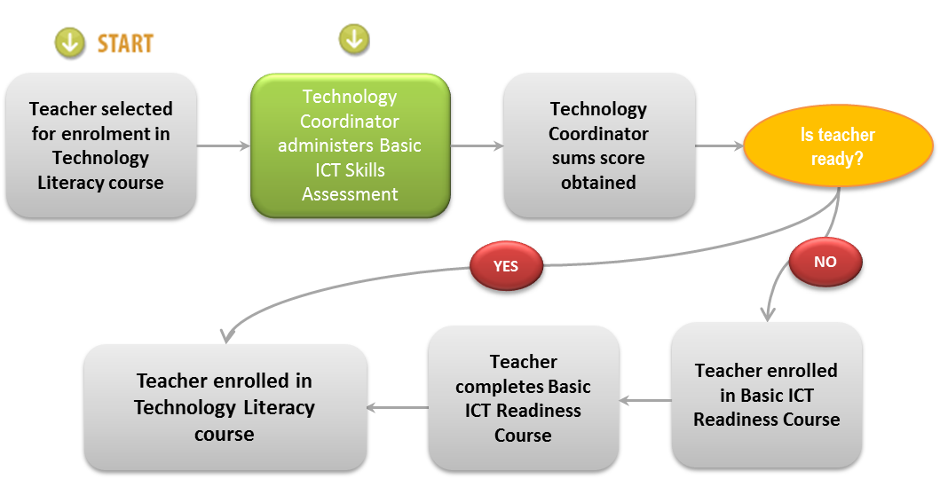
Test Design
- Principles
  - The assessment will not be timed and as such may last up to one hour.
  - The test consists of 25 specific tasks each of which are independent of the other.
  - Candidates will be supervised while taking the test.

- Scope and demand of tests
The test matches the identified requirements of the Technology Literacy for Educators and is organised into FIVE skill areas:
    - Basic operations
    - File and folder management
    - Navigating web-based resources
    - Document creation
    - Working with e-mail

- Pass mark
The test has a predetermined pass mark in the range of 17–19 out of 25 (dependent on whether system being used has a CD-ROM drive).

- Form of questions
  - The test consists of independent hands-on tasks that may be done on a netbook, laptop or desktop computer.
  - Each question is in the form of a task which may be accomplished in a range of ways. Whilst only one of these ways is likely to be optimal, all possible ways will be credited.

Skill areas and mark allocations

Mark allocations
- Skill area 1 Basic operations 4–6 marks
- Skill area 2 File and folder management 3 marks
- Skill area 3 Navigating web-based resources 6 marks
- Skill area 4 Document creation 5 marks
- Skill area 5 Working with e-mail 5 marks
Total 23-25marks

Assessment Protocol
- Principal identifies teacher as candidate for enrolment in Technology Literacy course and schedule a one-one meeting to discuss the staff member’s ICT professional development programme.
- During meeting, Principal establishes:
    - The importance of the integration of ICT in the delivery of the curriculum;
    - The importance of continuing professional development in the life of the teacher; and
    - The vision of the school for educators, support staff, and the leadership themselves to be skilled in the selection and effective use of appropriate ICT resources.
- During the meeting, the Principal also explains that the nature of the delivery of the Technology Literacy course and the need to ensure that the staff member is ready to undertake this mode of study.
- Principal indicates that the Technology Coordinator has been asked to administer a Basic ICT Readiness Assessment and report the result of the test to the Principal.
- The Technology Coordinator schedules a session time for the test that is mutually agreed by both parties (Technology Coordinator and Teacher).
- The Technology Coordinator ensures that the room, equipment, services, media and files are ready for use.
- At the designated time, the Teacher is asked to take a seat at the designated location and the Test Instructions are read from the document Instructions to Test Takers after which the test is administered.
- When the test is complete, the Technology Coordinator should:
    - Review the observations with the Teacher
    - Ask the Teacher to sign the observation checklist to indicate agreement with the observations recorded; and
    - Request that the Teacher check with the Principal to discuss the feedback and the way forward.
- After the Teacher has exited the room, the Technology Coordinator should:
    - sum the scores for each section;
    - compute the overall score;
    - record any additional observations and/or comments on page 2 of the Observation Checklist and Evaluation Report; and
    - sign and date the report
- The Technology Coordinator should present the completed Observation Checklist and Evaluation Report to the Principal.
- The Principal should convene a follow-up meeting with the Teacher within two days to:
    - discuss the results of the Basic Readiness Assessment
    - indicate which course the Teacher will be enrolled in and the details of that course.

Test Instructions
You will now be assessed to determine your Basic ICT Readiness. You have been provided with a computer system as well as a range of storage media. Listen carefully to the instructions as they are read then perform the task requested. You may request that an instruction be repeated however I cannot assist you with carrying out the task.
- Check voltage on equipment and connect to the appropriate power outlet. When you are confident that the power supply is correct, start up your computer system. Record observation as A1.1, A1.2
Note to Assessor: If computer system has a CD-ROM drive, go to step 2, otherwise, go to step 3.
- Open the folder Shapes located in the Designs folder on the CD-ROM and make a written note of the number of files in the folder. Record observation as A1.3
- Connect the provided USB flash drive to your computer system and confirm that the drive is mounted (that is, being seen by your system and can be accessed). Make a written note of the drive letter assigned to the USB flash drive. Record observation as A1.5
- Create a new folder named Documents on your USB flash drive. Record observation as A2.7
- Create a new word-processing document. Record observation as A4.16
- Retrieve document \BIRA\Intro from the CD-ROM | USB flash drive. Copy all the text in current document and paste in new document. Record observation as A4.17, A4.19
- Open a web browser and navigate to cnn.com. Record observation as A3.10
- Navigate to the Technology section on the home page. Record observation as A3.11, A3.12, A3.13
- Copy the second paragraph of the third lead story and paste it into your document, as unformatted text, as paragraph 2. Record observation as A4.18
- Save your document on your USB flash drive in the Documents folder as A4dot19 then close your word processor. Record observation as A4.20
- Go to the Commonwealth of Learning’s website at COL.org. Navigate to the Resources > Publications menu and download and save the publication — A Basic Guide to Open Educational Resources (OER) on your USB flash drive in the Documents folder. Record observation as A3.14
- Log in to your Hotmail | Gmail | Yahoo Mail account. . Record observation as A3.15
- Retrieve mail from < Assessor’s name > which was sent from < Assessor’s e-mail address > Record as observation as A5.21
- Download the attachment and save on your USB flash drive in your Documents folder. . Record observation as A5.22
- Compose an email to <assessor’s e-mail address> and send a Cc. (courtesy copy) to <designated repository>. Set subject to Basic ICT Readiness Assessment – Firstname Lastname, School. In the body of the email, write the text ‘The document produced and the two documents downloaded are attached.’ . Record observation as A5.23
- Attach all the files in the Documents folder on the USB flash drive to the e-mail. Record observation as A5.24
- Send the e-mail. Record observation as A5.25
- Log out from the e-mail system.
- Close the web browser.
- Safely remove the USB flash drive from the computer system. Record observation as A1.6
- Remove the CD-ROM and place it beside the computer system. Record observation as A1.4
- Shut down the computer system.
The assessment is now complete. Please give me a few minutes to make some additional notes, after which I will invite you to review the record of my observations and sign if you are in agreement with what I have noted.
Note to Assessor:
- Make sure that you have placed a check mark [✓] beside EACH task or “NA” beside Tasks 3 and 4 if they are not applicable.
- When you the finished recording your observations, invite the test taker to review your observations (Sections A & B) and sign if he/she is in agreement.

Advise the test taker of the procedure to retrieve his/her test result.

Setup Instructions
- Hardware, software, media and services needed
  - Desktop computer system, notebook or netbook
  - Web browser
  - Word processor
  - USB flash drive
  - CD-ROM
  - Internet service
- How to setup CDROM
  - Format CDROM
  - Create the following folder structure and add the files shown.
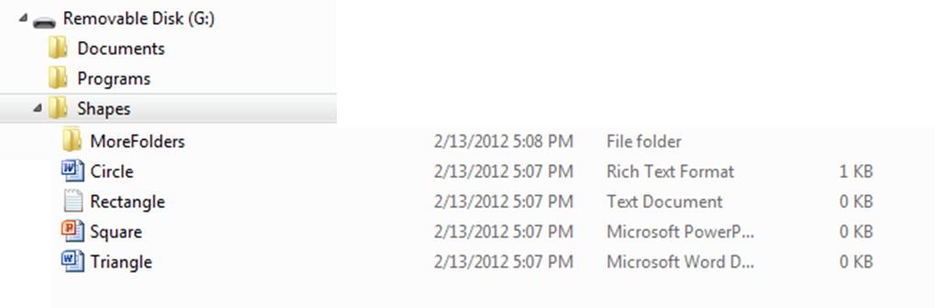
- How to setup USB flash drive
  - Format the USB flash drive.
  - Create a folder BIRA
  - Copy the Introductory Paragraph to a Word/WordPad/OpenOffice document and save as intro.rtf.
- Send an e-mail to the test-taker with the subject Basic Readiness Assessment. Attach the file created immediately above.

http://www.iste.org/Libraries/PDFs/Essential_Conditions_2007_EN.sflb.ashx

